PRODUCT CONTEXT

SAN LUCA MEDICAL CENTER

Management System

**HMS DOCUMENTATION**

1.Executive Summary

1.1Project Overview

Taking into consideration the latest events related to the Pandemic Situation with Covid19 , the field that got an irreplaceable importance is absolutely medicine and technology improvement. Hospital Management System came into the picture of hospital management as early as 1960 and have ever since been evolving and synchronizing with the technologies while modernizing healthcare facilities. In today’s world, the management of healthcare starts from the hands of the patients through their mobile phones and facilitates the needs of the patient.

At the past, handling patient invoices and appointments in hospitals and clinics was a chaotic scene. A methodical approach has evolved over time with the launch of San Luca 's Clinic Management Software. The best feature about this program is that it has decreased the use of paper by centralizing all vital data in one location. In terms of medical health records, doctors may easily coordinate with other departments. Because medications, bills, and other calculations are all kept digitally, the software has helped save time. This allows doctors to focus on their primary duties.

At first, HMS was created to address the challenges of organizing all of the paper work for each patient linked with the various departments of hospitalization while maintaining confidentiality. HMS allows personnel to handle all patient paperwork in one location, minimizing the amount of time they spend organizing and evaluating paperwork.

When it comes to the advantages and benefits of creating a Hospital Management System, we mainly focus on Technology that saves time, improved efficiency due to the decrease of human errors

which are less likely to occur . Moreover, data security and retrieval accuracy are now achievable.

The system is cost-effective and simple to manage. Patient data is easily accessible, and the patient's medical history is accurate.

In our project we have reflected the features of HMS mainly supported by the system of San Luca Medical Center. By having their own site, appointment widgets will be integrated onto the site. Patients visiting the hospital’s website can book online appointments with ease. The most unique feature would definitely be automatic notification which can be sent to customers on test results. Lab notifications like email, SMS of the test reports sent from the Automated Lab notification module.The patient will have an Integrated Billing with treatments, Lab and Radiology. Alerts will be sent on Discount Authorisation. Automatic due capture, Option to bill before and after consultation.For every patient that needs a consultation at every moment there will be an online chat which will give them the opportunity to have a conversation with one of the specialists of the field at any instant moment.

Moreover. This system will be related strongly to the system of lab management, pharmacy management, prescription management, billing management and appointment management. This HMS will allow the administrator to view all of a patient's data from a single system with just a few clicks. Information such as the patient's medical history, current sickness, doctors involved, test results, billing information, and much more. These details will aid in the connection of the patient's dots, such as precise diagnosis, treatment, and medication.

To provide increased data security, by implementing HMS at San Luca Medical Center, we will ensure that patient data is kept completely secure. It can only be accessed by a small number of people who have been given permission. With HMS, all of the data is saved on a server or in the cloud, and you only need to keep your login information safe.

In Conclusion, San Luca Clinic Information Management System software will  
deliver superior healthcare delivery for doctors, clinics and hospitals. Implementing the best practice management software for our hospital is highly recommended. Being an industry that’s sensitive by nature, it’s extremely important to use the right software to bring in more efficiency in the management for hospitals, clinics and doctors, and satisfying

patients with a speedy service.

1.2 Purpose and Scope of this Specification

The Hospital Management Information System Software is created with its main purpose to enable quick access to patient data and This medical software helps in generating patient bills and electronic test reports. Not just that, the doctors can also see the previous medical history and prescribe medicines accordingly. The Hospital Management Software serves you right as it helps you capture the right information in no time. It helps in issuing patient bills, keeps a track of the stocks, and reduces the use of paper, by sending the reports through emails and in the form of SMSs. It will help you organize your OPD to be completely paperless, from scheduling appointments to paying bills, storing clinical data, and receiving prescriptions and lab findings. It also increases the hospital's management visibility; all information and data about the patient, doctor, and medicine may be quickly viewed by any department.

Moreover, another important purpose of this project is to ease to Access System Facilities. The System will provide it easy to get access to the management system facilities for the authorized users and keep it safe from unauthorized users. It will develop in streamlining the accurate reporting with the help of updated and accurate records.HMS will provide accessand use to all the data refer to a patient via a system that is useful and efficient . Information including patient history, current symptoms , doctors involved, tests reports taken, billing information and many more can be made visible to the user. These data will help to connect the dots about the patient, like specific diagnosis, related treatment, and medication.

At last, the system is going to provide efficiency related to the costs. HMS not only saves time in the hospital, but it also saves money by reducing the number of people working on the manual data input and paperwork system. His installation will reduce human intervention in the system, reducing the likelihood of human-caused errors.

2.PRODUCT SERVICE DESCRIPTION

When it comes to the private healthcare services such as San Luca Medical Center, we can argue that the most important feature is that the Medical, financial, administrative, legal, and compliance aspects of a clinic 's operations need to be all managed by an integrated information system.

Regarding to the appointment system, the software will indicate Central integrated smart calendar for your doctor's appointment.It will setup flexible rate plans, create bills, collect payments and issue printed bills and receipts on your letterhead! Instantly provided printed bills and receipts customized with your clinic logo and details. Package management, complicated sharing arithmetic with doctors, outsourcing and insourcing partners are all offered with advanced capabilities. This will save you time and make your operations more efficient.

Moreover, its focus on pharmacy, stores and lab the software will support stock indenting, distributed stores and lab management. Eventually it will Integrate billing, sample collection, automated lab, and electronic test reporting all of which contribute to a more connected experience.

Furthermore, HMS allows your lab to go completely paperless! With connected flows, we can now enable digital transformation. Reduce reporting time, adhere to industry standards, and improve service delivery. Billing can be linked to the Lab using the connected system. Technicians can look at billing requests, collect samples, report results, print reports, and email them. The reports will be error-free thanks to advanced error-checking formulas. HMS also helps with lab automation by reading results from lab machines automatically.

With the Patient Management Software, San Luca Clinic may now improve their services for the betterment of their patients. This program makes it simple to manage patient admissions, allowing hospitals to add bills, bed costs, schedule admission dates, and discharge patients without delay. This is, without a doubt, the best dedicated software for increasing the performance of all activities.

To sum up our software that we have created allows you to digitize every part of your patient interaction. Medical Record Software, makes it easier to record medical information. This simple system is a boon to Clinics, Hospitals, and Doctors because it allows you to quickly input medical data in customisable forms and read patient history, treatments, diagnoses, and much more all in one location.

USER CHARACTERISTICS

ADMIN

**Admin** has the full access to the system which means he is able to manage any activity with regard to the system. He is the highest privileged user who can access to the system.

Key functions: •Access patient record, doctor Record.

•Add new doctor entry in system database.

• Confirm Payment and Generate Bill.

• View Records.(Total no of patients treated, doctor added/remove, consultant fee). PATIENT Patients can choose the best preferred appointments from the options provided and can also change the appointment schedule or cancel it. After appt. is confirmed by the respective doctor they can pay their consultant fee online. Patients have access to only their records.

Key functions: • Make appointment. • Cancel appointment. • Update Details. • Payment. •View Payment History.

DOCTOR

Doctors can view the patient appointment list and provide the confirmation or make changes in the appointment list if required. Doctors have access to only records of those patients whom they are treating. Key functions: • Confirmation of appointment. • Cancellation of appointment. • Modification of appointment list. • Add Prescription.

CONSTRAINTS

• System is wirelessly networked with an encryption.

• System is only accessible within the hospital’s website only.

• Database is password protected.

• Should use less RAM and processing power.

• Each user should have individual ID and password.

• Only administrator can access the whole system.

ASSUMPTIONS AND DEPENDENCIES

▪ Each user must have a valid user id and password

▪ Server must be running for the system to function

▪ Users must log in to the system to access any record.

▪ Only the Administrator can delete records.

USE CASE DESCRIPTION

(1) PATIENT

* REGISTRATION

DESCRIPTION - The new patient can register themselves and add their details like name,

age , gender, blood group etc. The patient entry will be made in the hms database.

PRE -CONDITION – The patient must be a new patient, If necessary fields left by user

then prompt user to fill the necessary fields.

MAIN FLOW OF EVENTS

1. Patient selects sign up in login module.

2. A registration form get displayed

3. Patient fills the required details.

POST CONDITIONS - Patient record is added to hms database.

* UPDATION

DESCRIPTION-The patient should be enabled to update his/her details and the changes

should reflect in hms database.

PRE-CONDITION – The patient must be a registered patient, The patient cannot update

details after treatment starts.

MAIN FLOW OF EVENTS

1. Patient logs in to the system.

2. Patient view his record

3. Patient selects update details.

4. Now patient may change the necessary fields.

5. Pop of update details.

POST CONDITION - The record of patient is updated in hms database.

*APPOINTMENT

DESCRIPTION - It shows users a list of available doctors, timings, dates and enables

patients to select the most suitable appointment date and doctor. The patient may also

the cancel the appointment.

PRE-CONDITION - The patient must be a registered patient, Patient can fix only one

appointment for a particular department.

**MAIN FLOW OF EVENT**

1. Patient first logs in to system.

2. View his/her record.

3. Create a new appointment or cancel the appointment..

POST CONDITIONS - patient details are displayed and a new appointment is fix or a

existing appointment is cancelled. The hms database is updated.

*PAYMENT

DESCRIPTION – It enables user to pay the consultant fee of Doctor online.

PRE-CONDITION - The patient must be a registered patient, If Patient don’t wants to pay

online he/she can pay by cash also.

MAIN FLOW OF EVENT

1. Patient first logs in to system.

2. View his/her record.

3. Appointment confirmed by the Doctor then go for Payment.

POST CONDITIONS – A Reciept will be displayed. The hms database is updated

(2) DOCTOR

DESCRIPTION- The doctor view patient record/ update his details and add description of

the treatment given to patient.

PRE-CONDITION – The doctor must be a registered doctor, System does not allow the

doctor to modify the qualification, hospital managed details.

MAIN FLOW OF EVENTS

1.Doctor logs in to the system.

2. Doctor may select view patient.

2.1 Patient record is displayed with treatment history.

3. Doctor add description of patient treatment.

4. Doctor may select appointment details

4.1 Appointment Requests is displayed with schedule.

5. Doctor confirm or cancel appointment.

POST CONDITION – The patient and doctor ‘s database are updated.

(3) ADMIN

DESCRIPTION - The admin add doctor, update docotr details and verify payment and

generate Bill/Reciept for the same.

MAIN FLOW OF EVENTS

1. Admin logs in the system.

2. Admin may add doctor new doctor.

2.1 admin fills the doctor’s details.

3. Admin view Doctor record.

3.1 Admin enters the doctor id in the system.

3.2 Doctor details are displayed, Admin can update details.

4. Admin Verify the payment submited by the Patient.

4.1 Generate Bill/Reciept and confirmation message for the same.

PRE –CONDITION - Admin must first log in with his/her credentials.

POST CONDITION - The hms database is updated.

The project's scope is as follows: 1)

Patients' information is gathered by simply writing the patient's name, age, and gender. When the Patient reappears, his information is updated. 2)

Bills are created by entering the price of each service delivered to the patient on a separate page, and then adding them all together. 3)

Patients' diagnosis information is usually documented on the paperwork that contains their personal information. To reduce the amount of paper in the office, it is destroyed after a certain amount of time. 4)

Children's immunization records are stored on pre-formatted seets that are retained in a file.

|  |
| --- |
| PRODUCT CONTEXT |
|  |

|  |  |  |  |  |  |  |
| --- | --- | --- | --- | --- | --- | --- |
| |  | | --- | |  | | PATIENT REGISTRATION  San Luca Medical Center's Patient Registration module is meant to manage critical information for the patient information chart, which is the first step in the demographics collection process. The patient's name, address, and contact information, as well as their birth date, employer, and insurance information, are all included.  For tracking visits, each patient has a unique ID.  Using secure electronic data interchange, automatically checks a patient's eligibility for benefits.  To reduce no-shows, sends updates via SMS text messages or email.    Inpatient Treatment Services San Diego - Alvarado Parkway Institute  Calendar Icon with Mark. Concept of Schedule, appointment 3501888 Vector  Art at Vecteezy  SCHEDULING & APPOINTMENTS  San Luca Software's Appointment & Scheduling module is designed to manage the efficient scheduling of patient appointments with doctors, laboratories, and radiology providers.  Patient scheduling that is quick and efficient  Appointments are available both online and offline. | | |  | | --- | | RELATIONOur project is directly related to San Luca Medical Center. It is designed to support these main modules:Patient RegistrationAppointments and SchedulingOutpatient ManagementInpatient Management | | MANAGEMENT OF INPATIENTS  The hospital management system's Inpatient Management module is designed to handle all inpatient department needs. As well as the admission, room, consultant, surgeon, diet, and advance payment information, are all put into this EHR system.  For each patient, there is a unique admissions number. | | MANAGEMENT IN THE OUTPATIENT SETTING  San Luca Software's Outpatient Management module is designed to keep track of all outpatient activities.  Patient Billing / Insurance Claims and Collections are simple.  Services that are organized, such as Consulting Services, Procedures, Medicines, X-Ray, Labs, MRI, and so on.  Organize your invoices, payment deadlines, and advance payments.  Patient notification, payment, and the next vaccine dose are all sent by SMS.  Produces a variety of reports and analytics to provide operational insight.  Intensive Outpatient Programs San Diego - Alvarado Parkway Institute | |

|  |
| --- |
| PRODUCT CONTEXT |
|  |

|  |  |  |  |  |
| --- | --- | --- | --- | --- |
| PATIENT DISCHARGE  Patient Discharge summaries are prepared automatically after a patient's discharge from a hospital or a physician's office.  Reflect the patient's main complaint, findings, and diagnosis in a clear and concise manner.  Keep track of the type of treatment you received and how you responded.  Make a list of recommendations in an easy-to-understand manner after you've been discharged.  Customizable, with the ability to integrate test data.    Payment gateway Computer Icons E-commerce Payment system, payment, blue,  text png | PNGEgg  BILLING  Billing includes all inpatient and outpatient consultations and services, including room rent, operations, deliveries, oxygen and other gases, consultations, nursing charges, laboratory tests, X-rays, ultrasounds, medicines, procedures, and so on.  Insurance firms receive paper-based and electronic claim billing services.  Payment For better revenue cycle management, set up overdue warnings. | |  | | --- | | billingpatient dischargelab managementCONSULTANT MANAGEMENT | | MANAGEMENT OF A LABORATORY  The pathology lab uses the Laboratory Administration module of the hospital management system to record and communicate information about the tests done.  Patient medical tests, exam reports, commercial records, and laboratory department activities are all well-managed.  Billing for both inpatients and outpatients is generated.  Test reports will be finalized by authorized workers and can be printed, emailed, and accessed via the portal and apps.  Finalized reports can be viewed on a screen before being sent to the ward.  Lab reports are accessible through a patient portal, allowing for a completely paperless solution.  When findings are available, an SMS/email is delivered to the patient.  Our EHR system is connected with our lab machine.  Several workflow components are available.  Science, Laboratory, Chemistry Blue Round Flat Design Vector Icon Isolated  on White Background Stock Vector - Illustration of internet, education:  176219371 | | Consulting icon business concept flat design Vector Image CONSULTANT MANAGEMENTThe San Luca system's Consultant Management Security Management module is used to handle software security. Role-based access configuration | |

EMAIL INTEGRATION

Can Luca software work with commercial email servers?

According on the practice's business rules, emails are sent at a number of adjustable events.





ACCOUNTING & FINANCE

Most commercially available Finance & Accounting software programs can be integrated with San Luca Software.

Integration with QuickBooks, Tally, and SAP is provided.

For inventory store management, the hospital management system's Inventory Management module is employed.

Maintain a purchase order with delivery deadlines.

Maintain the MRN and generate slips

Maintaining stock levels, reordering as needed, and displaying the necessary warning.

Payments paid at other departments can be used to bills.

DASHBOARDS AND ANALYTICAL TOOLS

San Luca Software's Analytics & Dashboards module includes dashboards for CEOs, Clinical Managers, Billing, and Nurses, among other positions.

The report will be automatically emailed at a predetermined date and time.



The San Luca l management system's Pharmacy Management module is used to manage several pharmacies. This module may be used to run a full-fledged pharmacy. It can also be connected to the primary billing system. When a patient picks up medications from a pharmacy, the charges are automatically transferred to the patient's account.

Oversee medicine distribution and stock management.

Receive prescriptions from consulting doctors and dispatch the dispensing unit to a specific patient without the need for manual involvement.

Prevent drugs from being distributed incorrectly.



MANAGEMENT OF PHARMACIES

MANAGEMENT OF INVENTORY

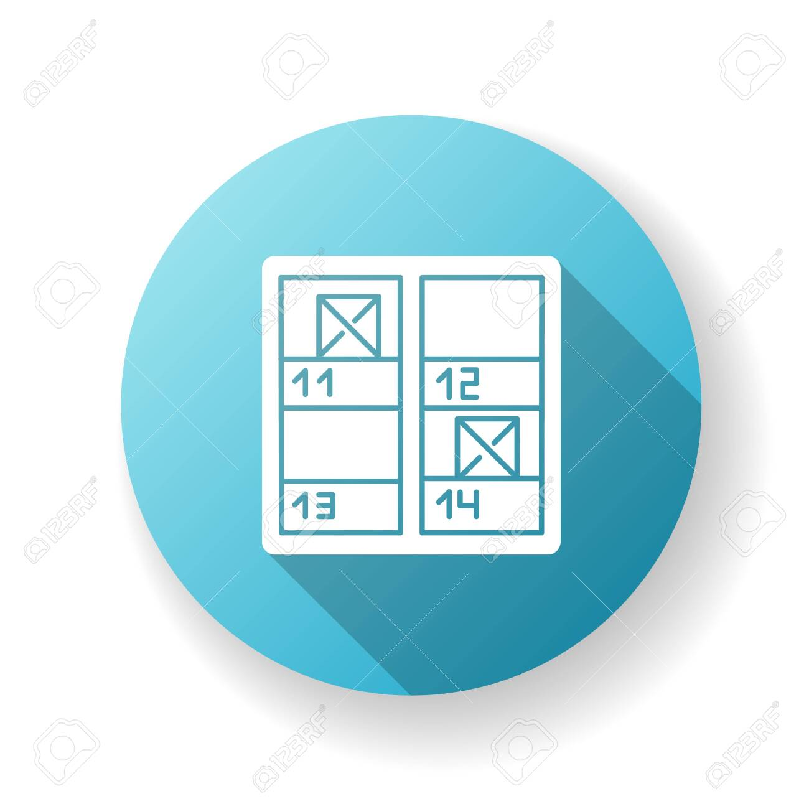



San Luca's Web Portal is in charge of managing web portal operations. The patient may view the schedule, make appointments, and communicate with the doctors in a secure manner.



MANAGEMENT OF THE RECEPTION AREA

San Luca's Reception Management module oversees front desk reception duties. This module may be used to check on the status of any patient or doctor, such as consultant availability, residence address, and patient room search.

Biometric

Device Interface

Commercially available biometric devices can be interfaced using the Biometric Device Interface System.

feedback

management

The hospital management system's Input Management module assists in gathering patient feedback.

MANAGEMENT

OF ATTENDANCE

The hospital management system's attendance management module aids in the recording of employee attendance.

This module may be used in conjunction with biometric attendance equipment to correctly and automatically record in-and out times.

MANAGEMENT OF ASSETS

The hospital management system's Fixed Assets module displays a detailed physical and monetary record of each and every Fixed Asset in the hospital.

Asset acquisition, capitalization, revaluation, exchange, and transfer records are kept.

NURSE MAANGEMENT

It Is possible to access the patient's vital signs, admission and nursing assessments, and nursing notes.

Nursing staff can use clinical information from a variety of specialties to arrange treatment. It also results in comprehensive health programs that include thorough assessments and reviews.

|  |  |  |  |
| --- | --- | --- | --- |
| |  | | --- | | Klinika San Luca | | WEB CAMERA INTERFACE Camera | App icon design, Screen design, App icon  San Luca software can connect to any web camera.  Speech, text to speech, voice input, voice recognition icon - Download on  Iconfinder    VOICE TO TEXT INTEGRATION    San Luca Software's voice-to-text integration works with any commercially available voice-to-text software.  Cities and Coronavirus (COVID-19) HEALTH PACKAGESan Luca Software's Health Package module assists in the bundling of numerous procedures, diagnostics, and drugs. It will be easier to advertise events to various patient populations. QR Code Scanner Interface QR Code Reader & Generator - Apps on Google Play **Commercially available QR code scanners may be interfaced using the QR Code Scanner Interface Software.**  **For identification, the patient utilizes a barcode and a QR code.** | | Nurse Icon Vector Art, Icons, and Graphics for Free Download  Asset Management System Icon, HD Png Download , Transparent Png Image -  PNGitem  484 School Attendance Illustrations & Clip Art - iStock  Feedback - Free marketing icons  Android fingerprint - Material Design |

|  |  |  |  |
| --- | --- | --- | --- |
| |  | | --- | | FEATURES  Klinika Mjekësore San Luca - Medical Practice - Overview, Competitors, and  Employees | Apollo.io | | PATIENTS Medical record Computer Icons Patient Hospital, pharma, blue, text png |  PNGEgg      Log In  Homepage  Upcoming Events  Reminders  Missed messages  Latest updates on other screens  Care team  Appointment and Scheduling  Admin Icon On Blue Button,white Background,clean Vector Royalty Free SVG,  Cliparts, Vectors, And Stock Illustration. Image 42161704.    ADMINISTRATOR    Creates and deletes all the roles  Has access to profile and documentation  Inputs information and data related to patients  Links patients with doctors  Organizes the appointments and schedules between doctors and patients | | Lead therapist  They have access to doctors and healthcare partners  All patients treated at the clinic  All doctors employed at the clinic  Profile and medical history of patient  Finance and account information  DOCTOR  They are provided access to certain modules:  Profile of doctors and their schedules which can be limited  List of patients  Limited medical history of patient and their previous diseases, treatment changes and notes  HEALTHCARE PARTNER  It has a wider access to patients and doctors data and information regarding medical history.  He plays the role of a doctor’s manager  Finance information about every patient  Billing history and insurance  Legal information  MANAGEMENT OF ASSETS    The hospital management system's Fixed Assets module displays a detailed physical and monetary record of each and every Fixed Asset in the hospital.  Asset acquisition, capitalization, revaluation, exchange, and transfer records are kept.  NURSE MAANGEMENT  It Is possible to access the patient's vital signs, admission and nursing assessments, and nursing notes.  Nursing staff can use clinical information from a variety of specialties to arrange treatment. It also results in comprehensive health programs that include thorough assessments and reviews. |





FUNCTIONAL REQUIREMENTS

Patient Registration is a requirement for the Hospital Management System project.

The Hospital Management System project must be capable of handling all of the patient's lab test results.

View, delete, update, insert, and search are all available to an authenticated registered user. Once the patient has been discharged, send a text message saying "thank you" and "get well soon."

Previous visits by the patient, including details about the doctor and a time stamp

The patient's whole radiological history may be viewed, deleted, updated, inserted, and searched by an authenticated registered user.

View, delete, update, insert, and search are all available to an authenticated registered user. Allergy information for the patient

The project for the Hospital Management System must be able to manage the Patient Queue System.

The Hospital Management System project must be able to manage the view of waiting patients from the perspective of the doctors.

The Hospital Management System project must be able to deal with a variety of situations.

The patient's whole medical history

Calculate the number of patients serviced each time a doctor sees a patient so that payment may be provided based on that number.

View, delete, update, insert, and search are all available to an authenticated registered user. Prescription

View, delete, update, insert, and search are all available to an authenticated registered user. Request for a test

View, delete, update, insert, and search are all available to an authenticated registered user. Note from the doctor, containing earlier notes

The authenticated registered user has the ability to edit, insert, view, remove, and search the database. Notes about the Discharge

The Hospital Management System project must be able to deal with a variety of situations. Receipt

Integrated Pharmacy may be updated, inserted, viewed, deleted, and searched by an authenticated registered user.

Integrated laboratory may be updated, inserted, viewed, deleted, and searched by an authenticated registered user.

Integrated Radiology may be updated, inserted, viewed, deleted, and searched by an authenticated registered user.

The Hospital Management System project must be able to deal with a variety of situations. Billing

The authenticated registered user has the ability to update, insert, read, and remove information. and look for The call handling of another doctor (for Inpatient)

The authenticated registered user has the ability to edit, insert, view, remove, and search the database. Discharge of the patient to coordinate patient transfers and moves

The authenticated registered user has the ability to edit, insert, view, remove, and search the database. Within each ward, a comprehensive patient search is available.

Patient Admission System must be handled by the Hospital Management System project.

System for Ward Management

View, delete, update, insert, and search are all available to an authenticated registered user. System for Managing Beds

The hospital management system project must be capable of dealing with doctor visits to ward management.

Doctor's visit details, including doctor's details and ward details with time stamps, must be handled by the Hospital Management system project.

The hospital management system project must be able to handle doctor visits in addition to overall visits so that doctors may be paid depending on the number of patients seen/served.

The project for the Hospital Management System must be able to







NON- FUNCTIONAL REQUIREMENTS

Capacity

Today and in the future, the Hospital Management System must meet storage needs. For increased volume needs, the Hospital Management System must be scaled up.

Performance

In many conditions, the Hospital Management System must operate properly.

Security

Proper user names and passwords must be used to safeguard the Hospital Management System.

Availability

The Hospital Management System must be accessible 24 hours a day, seven days a week, with no bandwidth constraints.

Manageability

When the Hospital Management System experiences a reversible disruption, it must provide an alert.

Integrity of Data

The Hospital Management System's data must be accurate and dependable at all times.

Usability

A decent looking, user-friendly interface is required for the Hospital Management System.

Recoverability

A suitable data backup method is required for the Hospital Management System.

Interoperability

Another system's pieces or equipment must be compatible with the Hospital Management System.

Regulatory

All governmental criteria and limits must be followed by the Hospital Management System.

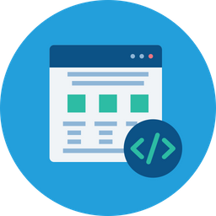

FUNCTIONAL REQUIREMENTS

The doctor should be able to access the patient's current information in order to double-check items as necessary.

A list of patients who are waiting to be examined should be available to the doctor.

Every time the doctor examines his patient, he should make a new entry in his patient's file. However, the receptionist must first provide permission.

The polyclinic's director should be able to access monthly statistics provided by the system in order to assess the situation and make the appropriate decisions.

The system should be transparent, and the patient should be able to observe what is going on.

A hardcopy file of the patient's records may be desired.

The doctor should be reachable by the patient.

His doctor will receive an email.

A patient is unable to view the profiles of the polyclinic's other doctors.

A patient can provide comments on their experience with the service.

A patient should be able to rate and remark on the polyclinic's service.

FUNCTIONAL REQUIREMENTS

Passwords are required for all user accounts.

By hashing passwords before storing them in a database, ethics will be preserved.

The user can change the password after he or she has obtained it, but not the username.

Because the format will be the same for everyone, editing usernames is not possible.

A new patient should be able to be added to the system by the receptionist.

The only person who can add a new patient is the receptionist. If the person already has a medical record file, he or she can fill out a form or import it.

The data that the receptionist enters while creating or updating a new account.

It's critical that all of the data be correct.

The patient's personal information should be editable by the receptionist.

The receptionist is the only one who can change a patient's information.

An existing patient should be able to be deleted by the receptionist.

The only person who can delete an existing patient is the receptionist.

A patient's whole profile should be visible to the receptionist.

The receptionist should be able to access the patient's current information in order to check items as needed or make necessary modifications.

A patient's medical file should be exportable by the receptionist. An XML file should be generated by the system.

The only person who can export a patient's medical file is the receptionist.

A new doctor should be able to be added by the receptionist.

A doctor's personal information should be editable by the receptionist.

An existing doctor should be able to be deleted by the receptionist.

A doctor's entire profile should be visible to the receptionist.

The receptionist should be able to examine the doctor's current information in order to check items as needed or make necessary modifications.

The receptionist should be able to see a list of all of the polyclinic's doctors.

The receptionist should be able to look up a certain doctor's information.

Because the polyclinic is expected to have a large number of doctors, having a search option would be beneficial.

The receptionist should be able to assist you in any way she can.

A hardcopy file of the patient's records may be desired.

The doctor should be reachable by the patient.

His doctor will receive an email.

A patient is unable to view the profiles of the polyclinic's other doctors.

A patient can provide comments on their experience with the service.

A patient should be able to rate and remark on the polyclinic's service.

NON -FUNCTIONAL REQUIREMENTS

Non-functional specifications

Non-functional needs, such as security, performance, maintenance, and dependability, exist in every hospital. These are critical features of the overall healthcare delivery ecosystem since they are not restricted to one or a few tasks but are all-encompassing necessities. These non-functional criteria can also be met by HMS.

Security

At every level of hospital operation, HMS manages massive amounts of data creation, information interchange, storage, and analysis. It gives robust, multi-layered security to all data transfers, and so protects the system from abuse or loss of information, since it is built on Cloud and other advanced digital technologies. The HMS platforms normally adhere to the country's most strict data security and privacy laws. Due to the fact that HMS is housed on Cyberattacks on hospital systems are safeguarded by cloud-based servers that are situated outside of the premises. Overall, HMS encourages openness, safeguards confidentiality, eliminates data theft, and provides a safe and secure environment in which hospitals may continue to operate.

Performance

HMS boosts the system's speed, agility, and efficiency by simplifying and integrating different operations. The platform includes modules for OPD management, IPD management, Cath Lab and diagnostics management, emergency care response, billing and payments, and operations, among other things. It has the capacity to provide users with role-based control, allowing them to utilize one element of the function or many functions while also assisting them in monitoring and tracking every activity required for healthcare delivery. As a result of such interoperability and HMS improves a healthcare facility's performance and capacities in treating patients because of its intra-operability and flexibility.

Maintainability

HMS technologies that work well are simple to maintain. They are often SaaS-based technologies that maybe changed and modified remotely without disrupting hospital operations. Its maintenance tasks may before-scheduled in stages depending on when the activity is at its lowest, and upgrading takes little time.

Reliability

HMS is very robust to any technological interruptions, outages, or breakdowns encountered by other technology systems since it is software as a service. It has the ability to function offline to some extent. From a data security standpoint, it is quite safe. Furthermore, a good HMS has a user interface that is intuitive and clever, making it easy to operate.

Conclusion

When it comes to catering to the demands of a healthcare institution, HMS provides a full solution. It is a very scalable solution since it can be modified to include new features or specific functionalities can be disabled based on the facility's needs. It also eliminates the need for a variety of technological solutions to serve various functions. In addition, good HMS solutions are white-labeled technology that allow hospitals to market themselves. HMS makes healthcare staff's jobs easier, giving them more time to focus on what they do best: caring for patients.

OTHER NON -FUNCTIONAL REQUIRMENTS

Response Time: Once the 'patient's information is validated, the system gives acknowledgement in less than a second.

Capacity: The system must be able to accommodate at least 1000 individuals at the same time.

User-Interface: Within five seconds, the user interface acknowledges.

Conformity: The system must verify that the Microsoft accessibility rules are met.

Maintainability:

Back-up: The system is efficient when it comes to data backup.

Errors: The system will keep track of all mistakes and keep a log of them.

Patient Identification: In order for the system to work, the patient must be able to recognize herself or himself while using the phone.

Logon ID and Password: Any users that utilize the system must have a Logon ID and password.

Adjustments: Any database modifications, such as insert, remove, update, and so on, may be synced rapidly and only the ward administrator can perform them.

Front Desk Personnel Rights: Front desk staff have the ability to examine any data in the Hospital Management System, as well as add new patient records to the system, but they do not have the ability to change any data.

Administrator rights: The administrator has access to all information in the Hospital Management System and can change it.

Performance Expectations

Response time—After verifying the patient's information and other data, the system will respond within one second.

Capacity—The system must be capable of supporting 1000 individuals at once.

User interface- Within 5 seconds, the user interface screen will respond.

Conformity

The system must adhere to Microsoft's accessibility guidelines.

Prerequisites for safety

If a catastrophic failure, such as a disk crash, causes extensive damage to a large portion of the database, the recovery method restores a previous copy of the database that was backed up to archival storage and reconstructs a more current state by reapplying or redoing committed transaction operations from the backed up log, up to the time of failure.

Security Prerequisites

All administrative and data input operators have unique logins, so the system can tell who is currently logged in. No intruders are permitted except system administrators, and no one can edit records or sensitive data.

Attributes of Software Quality

AVAILABILITY: The system must be operational at all times.

CORRECTNESS: A bug-free program that meets the client's exact needs and expectations.

MAINTAINABILITY: The capacity to maintain, edit, and update information as well as remedy system faults.

USABILITY: The program can be used over and over again without losing its quality.

ACCESSIBILITY: The system is accessible to the administrator and many other users, however each user's access level is restricted based on their job responsibilities.

ACCURACY: The information's/dependability. output's It is possible to rely on/be certain of the outcome.

STABILITY: The system's output/outcome will not vary over time. For a given input, the same output will be delivered every time.

Business Procedures

Want to bear responsibility for failures caused by faulty hardware.

The software would be maintained for a year under warranty.

Additional payments will be investigated and billed for future maintenance.

If an issue occurs as a result of a user's incorrect use. It will not be covered under warranty.

There are no refunds for the software.

ANALYSIS OVERALL

Multi-specialty hospitals may make progressive improvements in appointments, billing, processing patient history, and enhancing the productivity of hospital employees by utilizing a well-equipped hospital management system. The program may relieve Health Care Workers of the responsibility of keeping patient data safe, structured, and easy to find, providing them more time and convenience to focus on patients. As a result, the patient's recuperation is improved.

Follow-up in a timely manner: The follow-up processes are also made simple. These technologies include capabilities for sending automated reminders and interacting with patients, giving the hospital a more customer-focused approach.

Rules-based Compliant:

The most important need for an HMS is compliance with local norms and regulations. Integrate features into government

It's critical to have data-sharing portals like SALAMA, MALAFFI, and NABIDH, as well as tax-filing platforms.

Because this is such a large investment, it is usually ideal to approach a software vendor who has been in the field for at least 8-10 years, has a strong local presence, and can give current user references.

Integration: If you're already up and running, you've probably already invested in a lot of equipment and clinical systems, such as accounting software, billing software, lab equipment, and so on. An HMS that can integrate with these systems would be a suitable alternative for you.

Server-based or cloud-based:

A web-based solution will be better because it will not take up space on your Operating System throughout the download and installation process.

It also ensures that the data is adequately backed up. Given that few people choose to retain private data on a local server, an HMS that can handle both cloud and local servers would be more useful.

Easy inclusion of extra branches: If you have branches in different geographic locations and want to expand, buying a system that allows you to easily add new branches is the best option.

Role of financial management:

If you can find a system that includes Revenue Cycle Management and Inventory Management in addition to all of the other functions, that would be the best option.

Hospitals and clinics are for-profit businesses that rely heavily on the money they produce. Hospitals are service-oriented businesses that rely heavily on referrals to earn income.

on the level of client satisfaction An HMS simplifies hospital management's workflow while also making hospital visits and follow-ups simple for patients, allowing for better patient care and satisfaction.

When compared to a system without one, an HMS may ensure a significant boost in customer satisfaction. In addition to financial system management, a high-quality HMS may help with insurance claim processing.

ORGANIZATIONAL REQUIRMENTS

Requirements of the Organization Availability

• The app will be available 24 hours a day, seven days a week.

• Because the program will be available to everyone with a computer linked to the Internet, any user will be able to view his or her data from anywhere.

• Because the data utilized by the users is particularly sensitive and time-varying, the application will be created in such a way that it will not be forced to experience downtime.

• The system's functioning will not be harmed by scheduled maintenance. Unscheduled application maintenance shall not enable the system to be offline for more than one hour in the event of a problem.

Latency

The latency of a web application is determined by two factors: the strength of the Internet connection and the size of the database.

• The efficacy of the retrieval algorithms data retrieved from the database

Monitoring

• The system will be created with security and dependability in mind. The user interfaces will be simple, and it is unlikely that the system would crash.

• The system maintenance group is responsible for generating periodic reports. These reports will be used not just to identify faults, but also to identify potential improvements to the system.

• Field validation will be utilized when attempting to log in, when a new patient is added, when a new doctor is introduced, when a doctor's or patient's personal information is altered, when a password is changed, and so on. When the input does not meet the requirements, a particular message will be displayed.

displayed to the user in order to alert them of the problem

• For the majority of conceivable error scenarios, instructive messages will be generated to be displayed to the user so that he is aware of the issue.

Maintenance

• The database for the system will be MySQL, and the server will be APACHE. As a result, the application will be maintained on these two platforms.

• The app will be built in modules so that it can be readily expanded. At any moment, new modules may be readily added to the program.

• A system restart should assist if there is a problem with the system. If it doesn't work, the server could be down, in which case you should contact the maintenance department.

• In the event of a software upgrade or bug fix, , users will be notified.

### Features For Patients

* Login (email, Face/Touch ID);
* Home page;
* Upcoming events;
* Reminders;
* Missed messages;
* Latest updates on other screens/sections;
* Care team;
* Appointment & Scheduling;
* Treatment Plan
* Chats
* Calendar with appointments;
* Check-ins/surveys;
* Payment;
* Health reports;
* Telemedicine solution (Video chats);
* My logs;
* Notifications;
* Support.

### Features For Doctors

* Login;
* Profile;
* Home page;
* Upcoming events;
* Reminders;
* Missed messages;
* Latest updates on other screens/sections;
* Manage Patients;
* Patient’s card;
* Notes about patients;
* Patient's calendar;
* Patient’s care team;
* Treatment history;
* Logs from Patients;
* Telemedicine solution (Video chats);
* Calendar with appointments;
* Manage Meetings;
* Basic Chat
* Notifications;
* FAQ.

**SOFTWARE DESIGN DIAGRAMS**

***4.1 Requirements Analysis***

**4.1.1 User Scenarios**

A user logs into the system. The user selects a user type: patient, receptionist, or doctor

The user selects a user type: patient, receptionist, or doctor The user gets forwarded to page c of the log in process.

The user provides his username and password, which are both

The reCaptcha 'I am not a robot' is checked by the user.

The user taps the f key to log in.

The user gets routed to his profile page if the data is accurate.

If the data is incorrect, an error message appears, and the user returns to previous step

Password should be changed

The user logs in using the processes outlined in US 01.

The user selects "Change Password" from the menu.

User enters both his old and new passwords (2 times)

The user taps the "Save Changes" button. "Password was changed successfully!" the user is notified if the old password is correct and the new password is the same in both areas.

The user is notified if the previous password is incorrect or the new password is not the same in both fields: "Password was not changed." Please try one more."

The receptionist completes the processes to log in. US 01

"Add a New Patient" is selected by the receptionist.

The receptionist completes all of the blank fields.

Receptionist double-checks that the information entered is correct, then clicks the "Add Patient" button.

Are you sure you want to keep going? YES OR NO

If no, don't do anything; we're still on the same page.

If the answer is YES, the system checks the data against the defined criteria.

The data is saved in the database and the account is created if validation is successful. The receptionist will be transferred to his or her home page after receiving the helpful message "Patient added successfully!"

If validation fails, useful notifications will appear, indicating the source of the problem so that the receptionist may resolve it and proceed to the next stage.

Follow the procedures in US 01 to log in as a receptionist.

"Add Patient" is selected by the receptionist.

The receptionist selects "Import data" from the menu options.

The receptionist clicks OK after selecting the data file.

"Add Patient" is selected by the receptionist.

Are you certain you want to keep going? NO/YES

If the answer is YES, the information is recorded in the database and an account is established. The receptionist will be sent to his/her home page after seeing the helpful message "Patient added successfully!"

If the answer is no, don't take any action; simply stay on the same page.

Receptionist's list of patients

a. The receptionist logs in using the procedures in US 01 b. The receptionist selects "Patients' list" c. A table containing all of the polyclinic's patients appears.

• Medical professional

a. Doctor logs in using the processes outlined in US 01 b. Doctor selects "My Patients" from the menu.

c. A table displaying all of his or her patients will be displayed.

7. Doctors' list (US 07)

a. The receptionist logs in using the instructions in US 01 b. The receptionist selects "Physicians' list" c. A table containing all of the polyclinic's doctors appears.

• Receptionist a. Receptionist logs in using the steps in US 01 b. Receptionist clicks on "Patients' list" c. A table containing all of the patients and a search box will appear.

Receptionist a. Receptionist logs in using the steps in US 01 b. Receptionist clicks on "Patients' list" c. A table displaying all of the clinic's patients will appear • Doctor a. Doctor logs in using the methods in US 01 above it

d. The receptionist fills up the name, surname, or both fields.

e. If any results are discovered, they will be displayed in table f. The table will be empty if no results were found.

• Doctor a. Logs in using the processes outlined in US 01 b. Clicks on "My Patients"

c. A table including all of his or her patients will be shown, with a search box above it.

d. The doctor fills in the name, surname, or both fields.

e. If results are discovered, they will be displayed in the table. f. If no results are found, the table will be displayed as blank.

9. US 09 – Find a doctor a. The receptionist logs in using the methods in US 01 b. The receptionist selects "Doctors' list" from the drop-down menu.

c. A table will be displayed with all of the physicians and a search box above it.

d. The receptionist fills up the name, surname, or both fields.

e. If there are any results, they will be displayed in the table f. The table will be empty if no results were found.

the receptionist logs in.

"Add a New Doctor" is selected by the receptionist.

The receptionist completes all of the blank fields.

Receptionist double-checks that the information supplied is correct, then clicks the "Add Doctor" button.

Are you sure you want to keep going? YES OR NO

If no, don't do anything; we're still on the same page.

If the answer is YES, the system checks the data against the defined criteria.

The data is saved in the database and the account is created if validation is successful. The receptionist will be sent to his or her home page after receiving the instructive message "Doctor added successfully!"

If validation fails, useful notifications will appear, indicating the source of the problem so that the receptionist may resolve it and resume the process.

User patient information to be updated.

a. The receptionist searches for a patient using the methods in US 08/a. b. For that specific patient, the receptionist clicks the "Update" button. c. A form with fields filled with the patient's current information appears. d. The receptionist makes the appropriate modifications.

e. The receptionist double-checks that the information submitted is correct. f. The receptionist presses the "Update" button.

g. Warning: Are you sure you want to keep going? YES/NO h. If NO, don't do anything; we're on the same page.

i. If the answer is YES, the system checks the data against the defined requirements.

j. The data is saved in the if the validation is successful. The receptionist will be transferred to his or her home page after receiving the helpful message "Patient updated successfully!"

k. If validation is required

SOFTWARE DESIGN AND DIAGRAMS

ACTIVITY DIAGRAM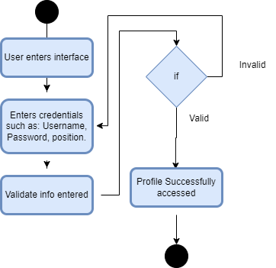

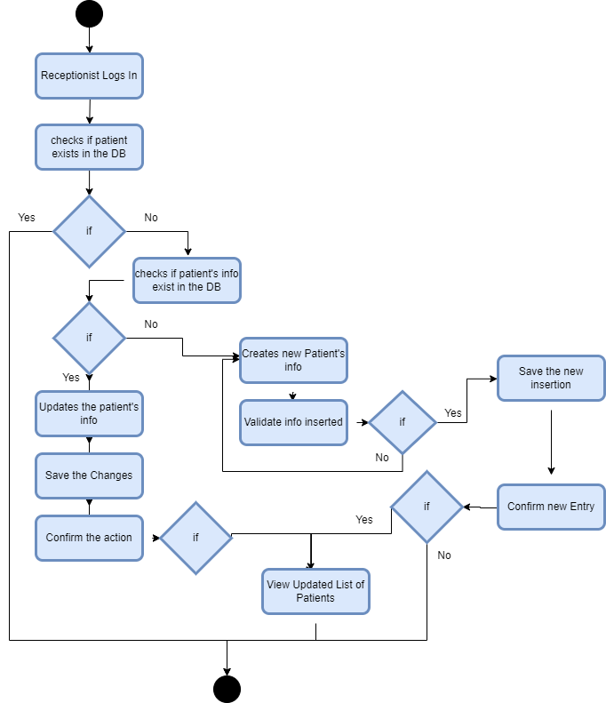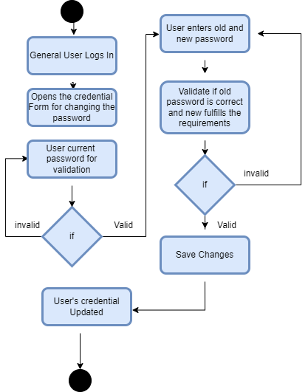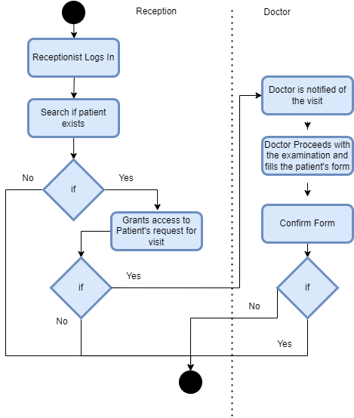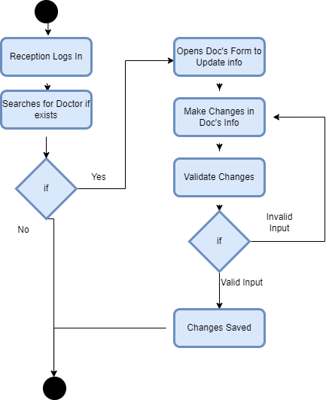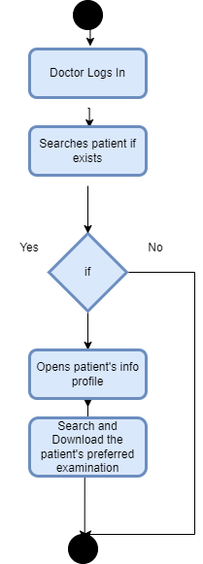

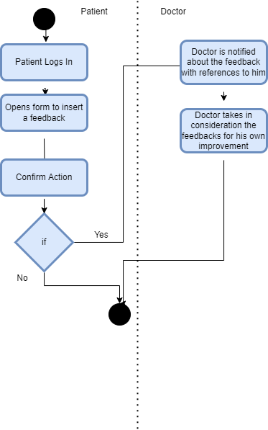

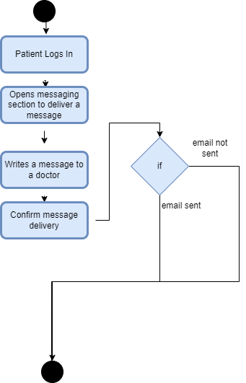

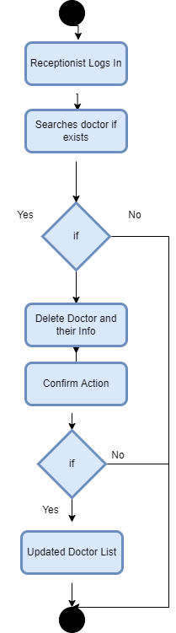

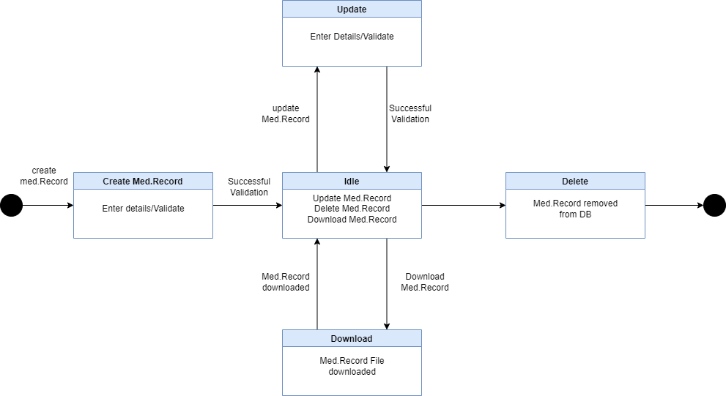STATE DIAGRAMS

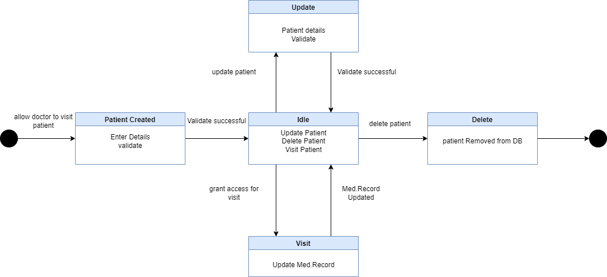

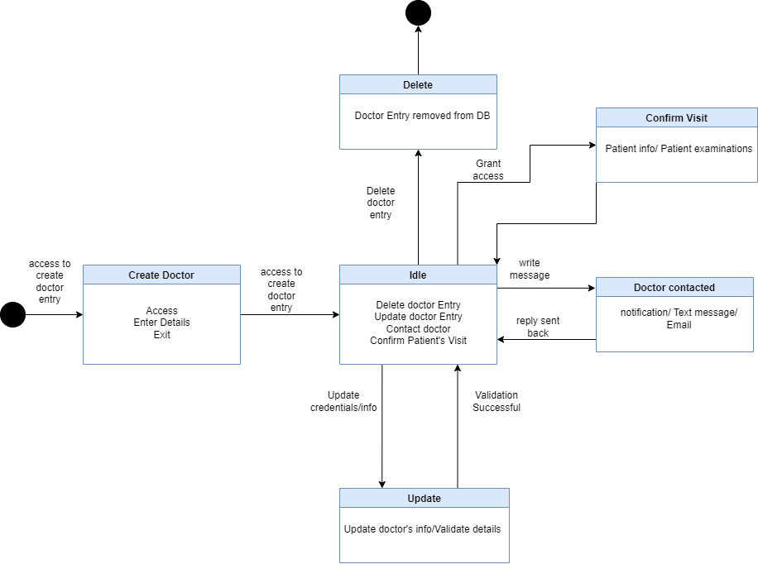

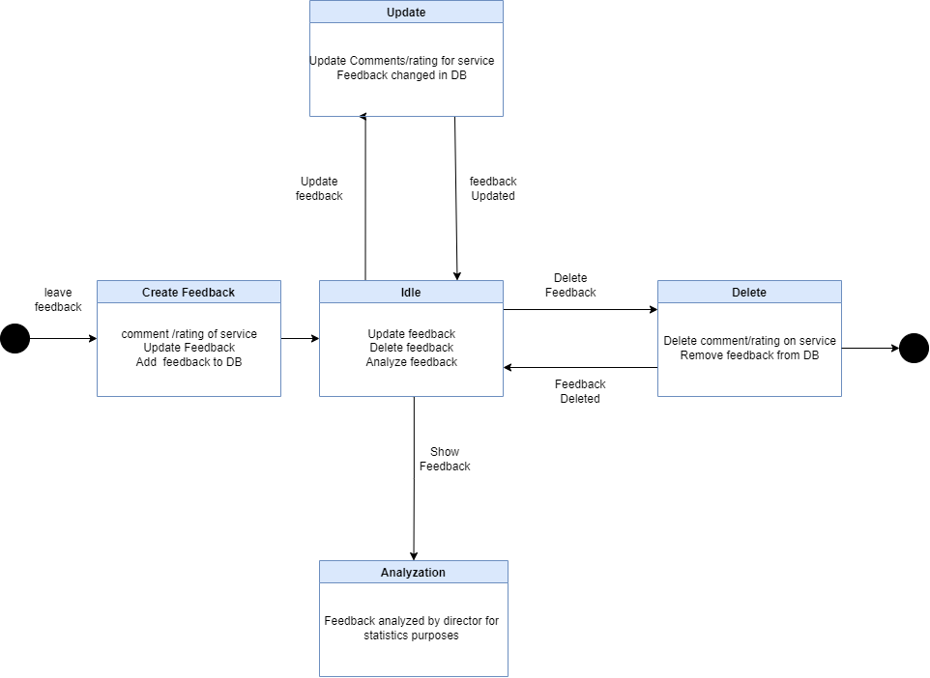

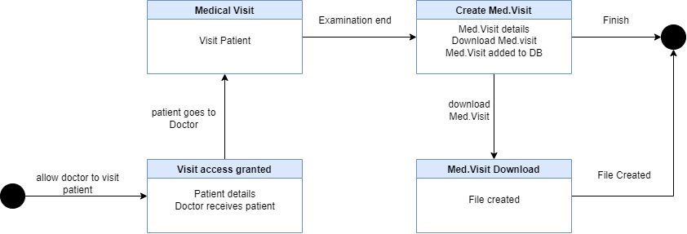

BPMN DIAGRAM

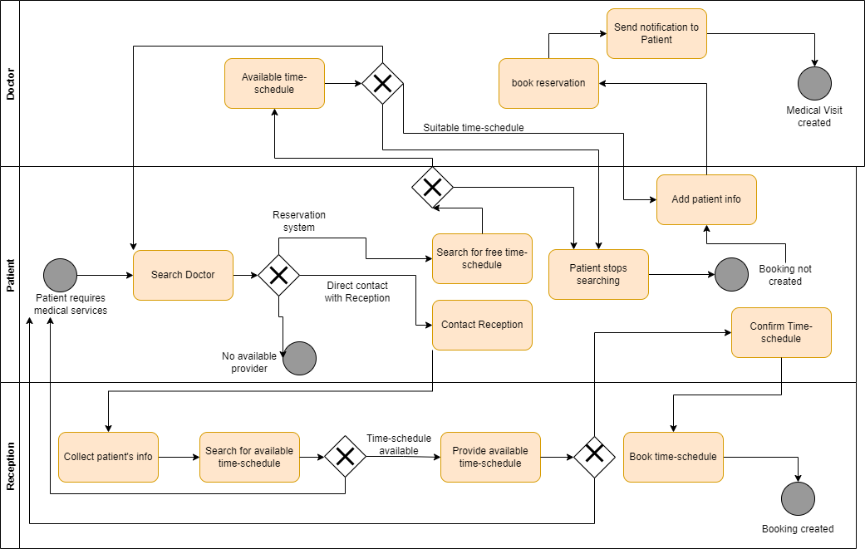

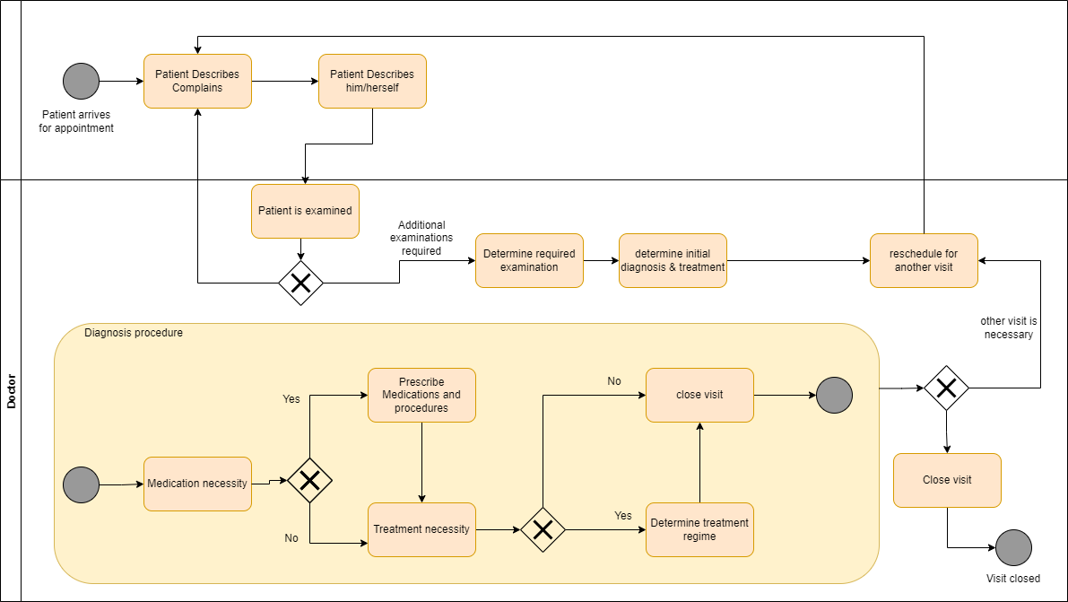

CLASS DIAGRAM

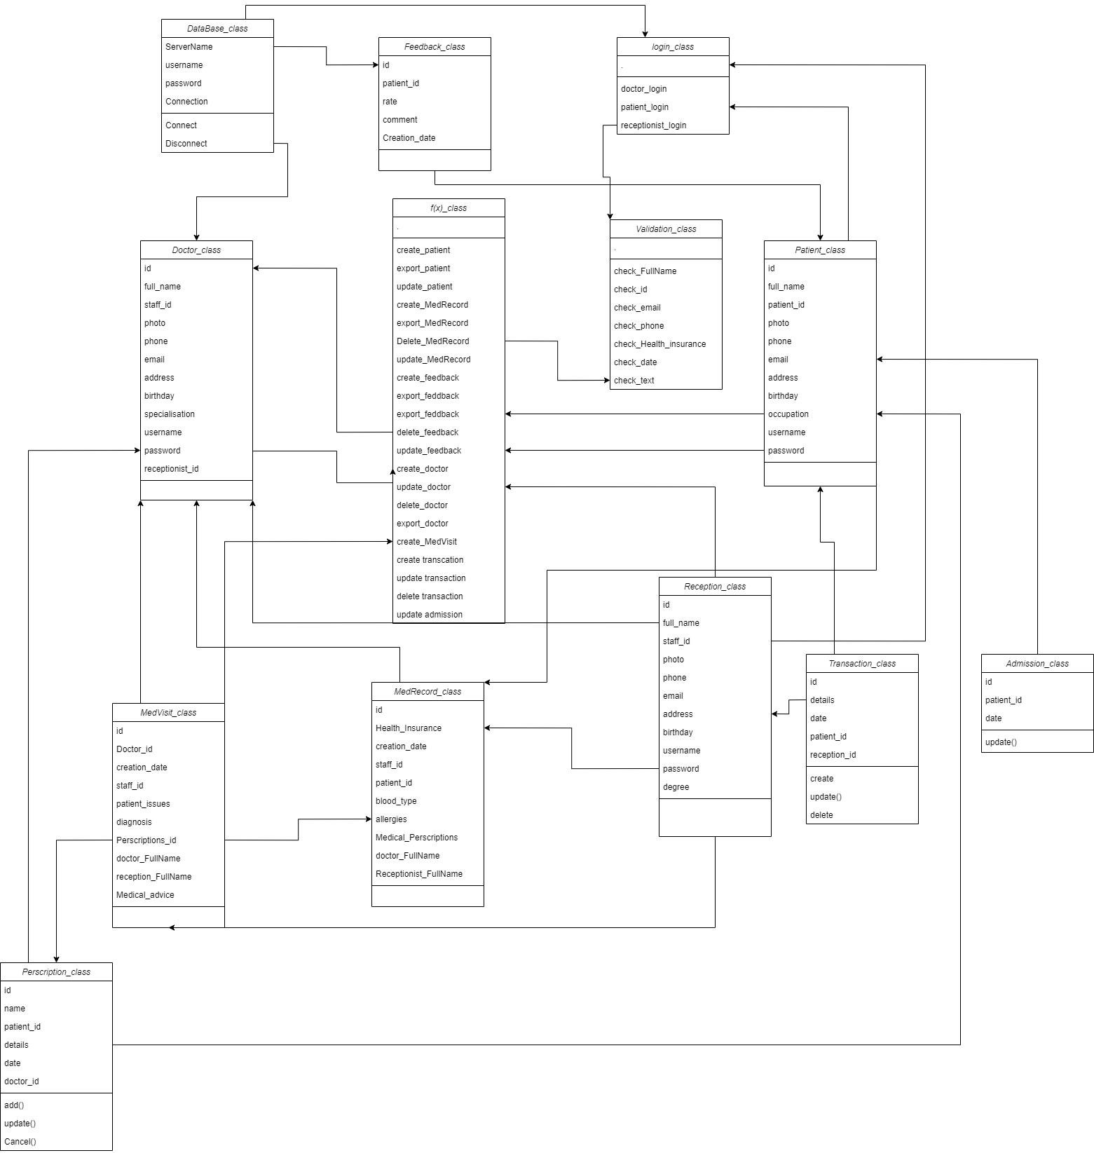

OBJECT DIAGRAM

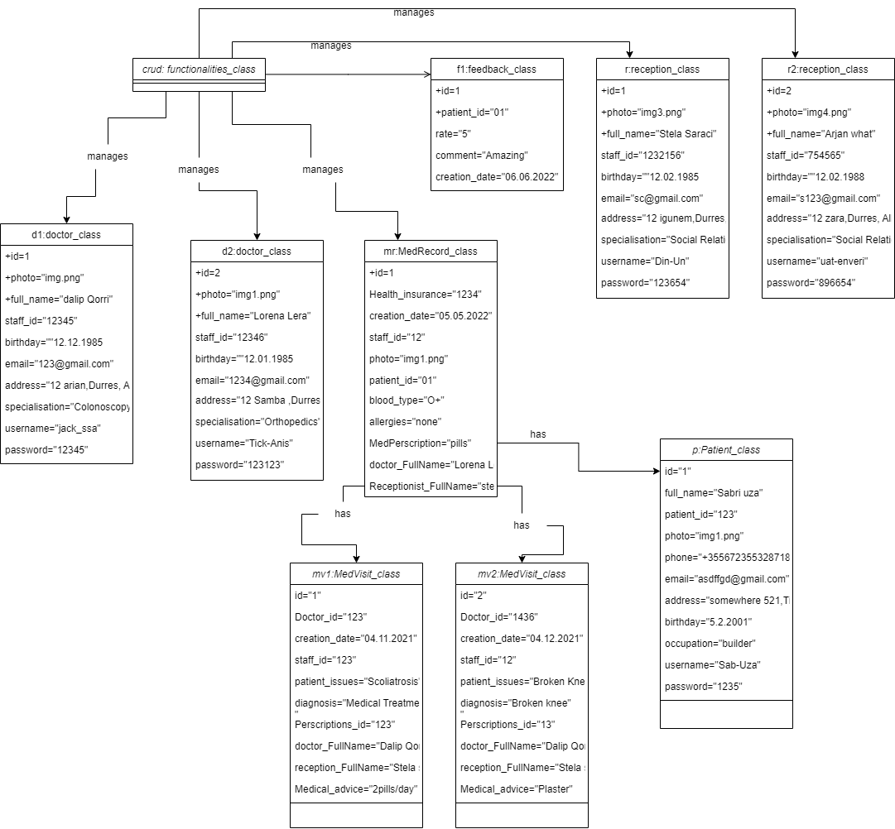

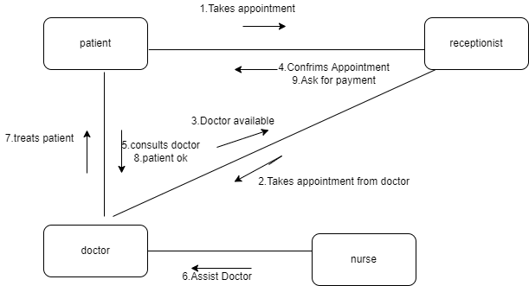

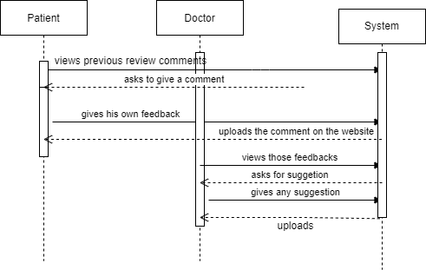

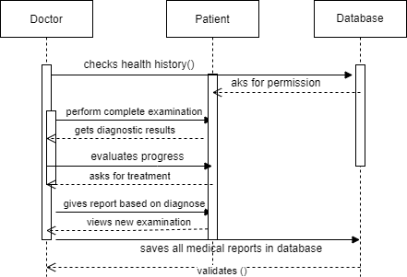

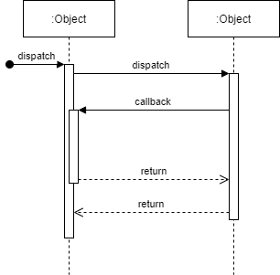

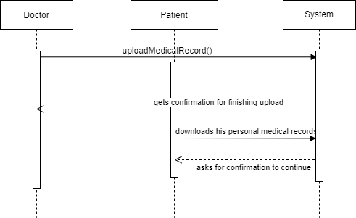

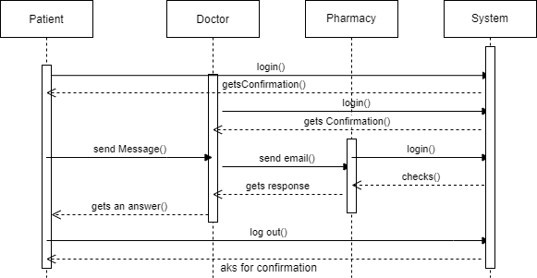

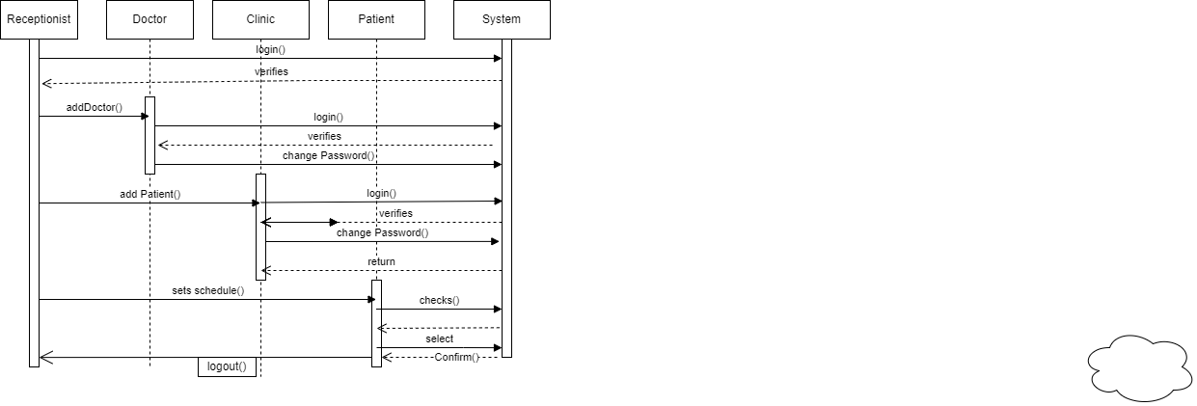

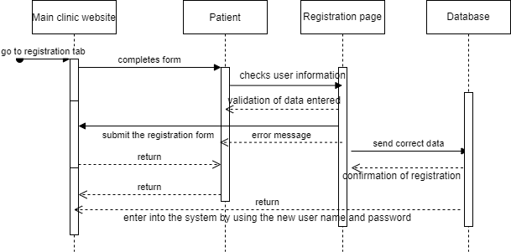

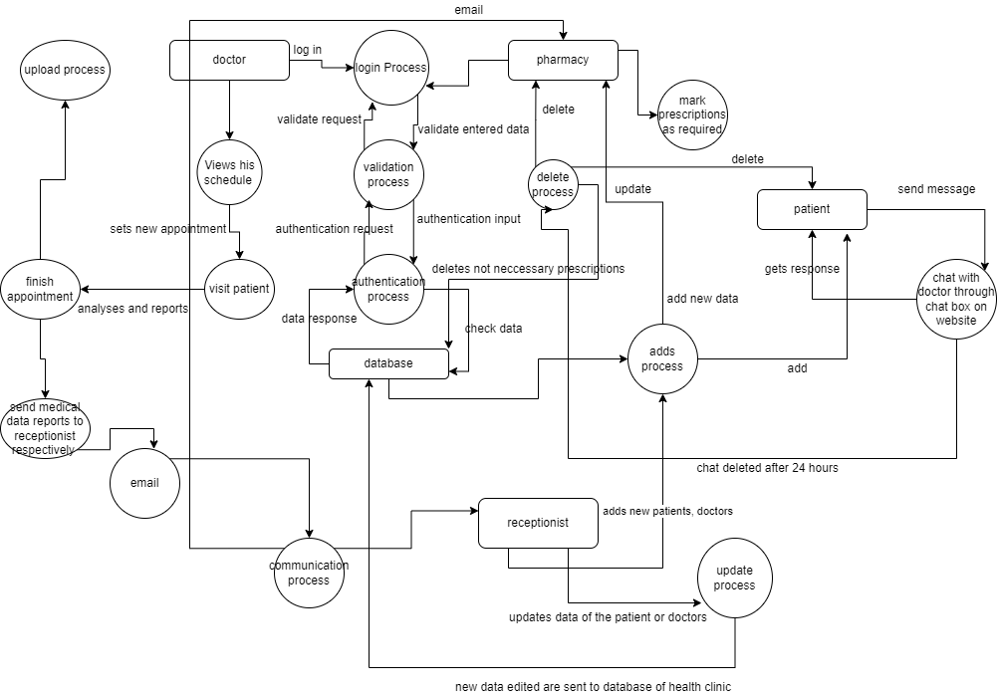

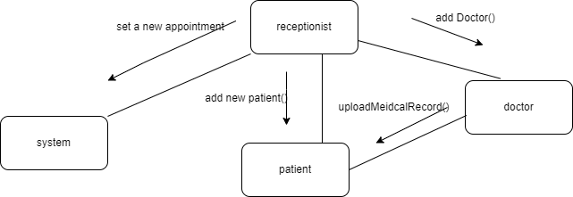

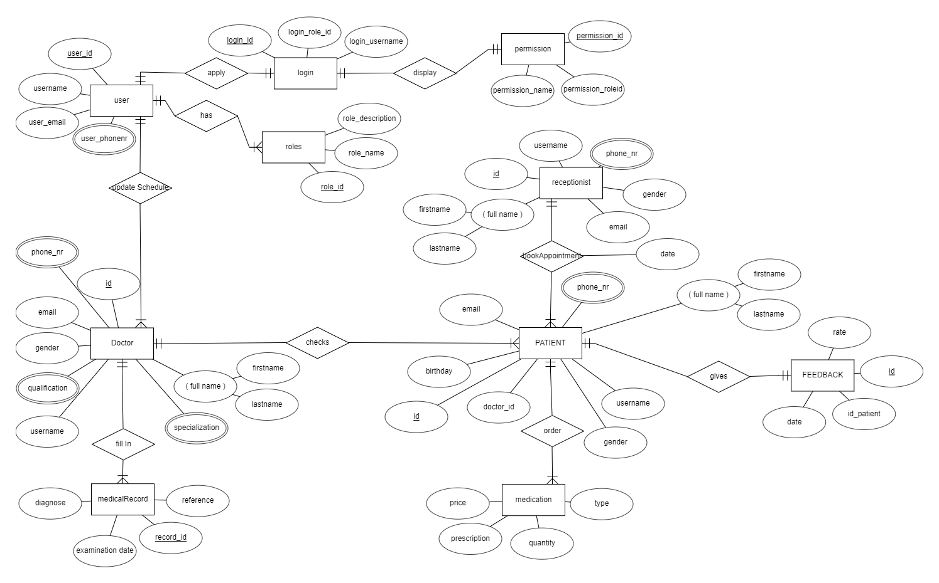

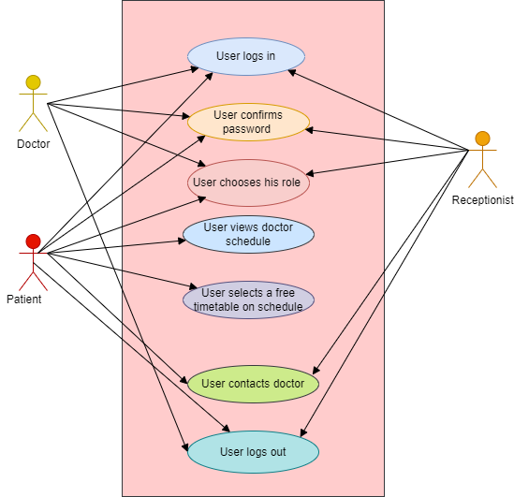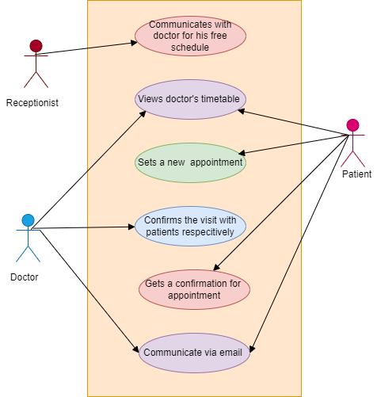

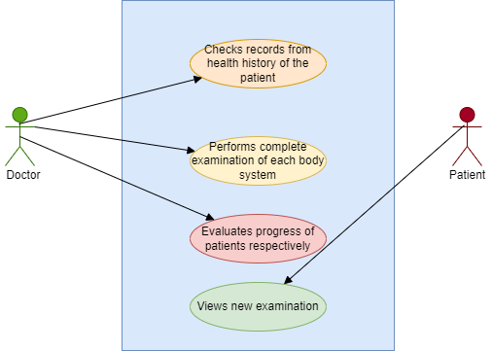

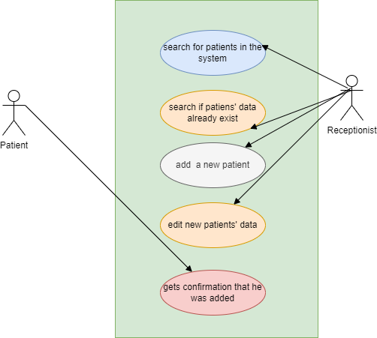

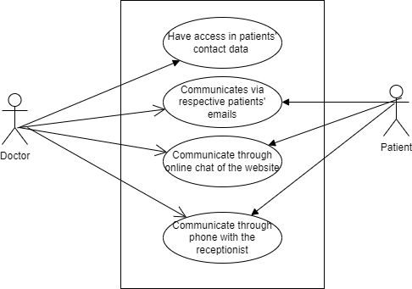

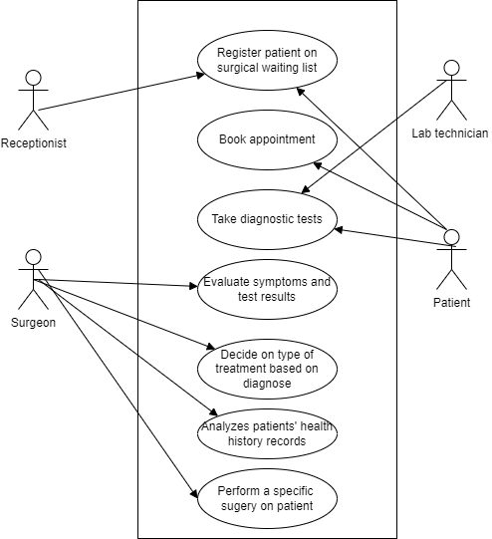

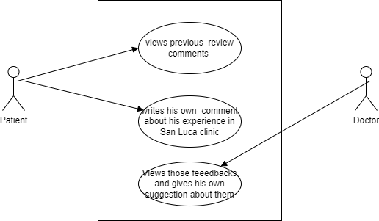

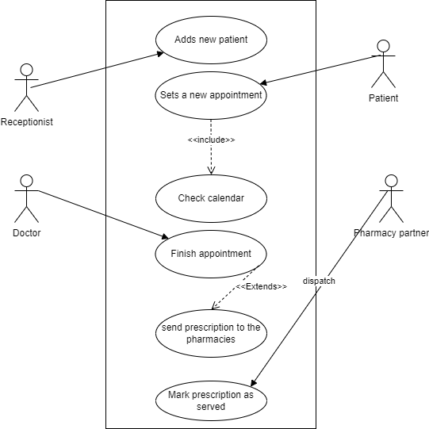

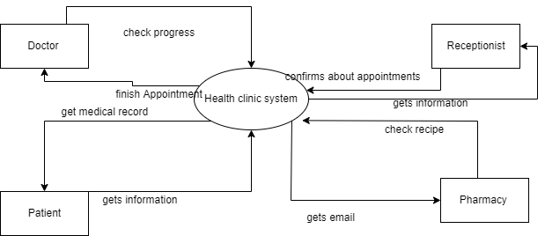

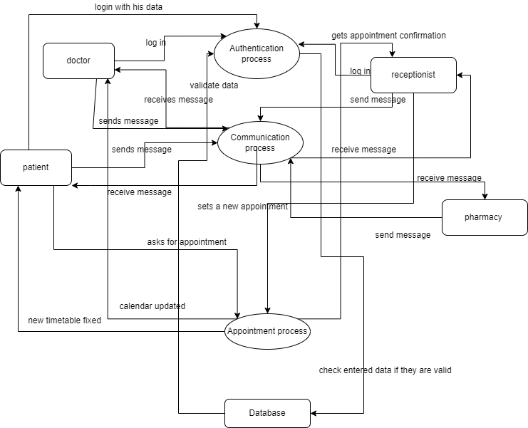

LOG IN PAGE

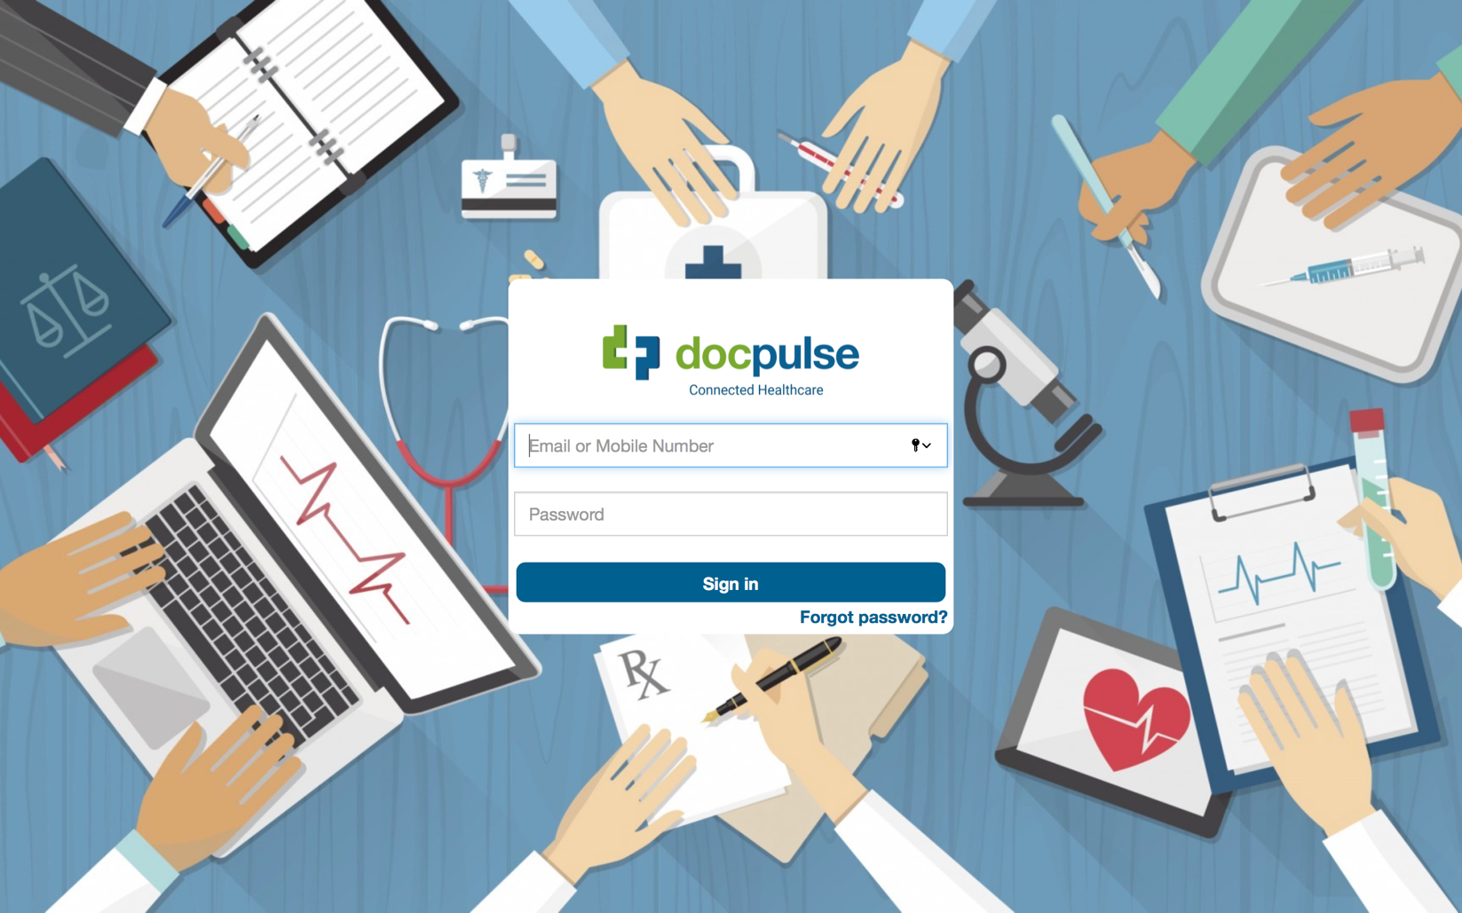

San Luca Clinic



IMPLEMENTATION TECHNOLOGY

CONTACT PAGE

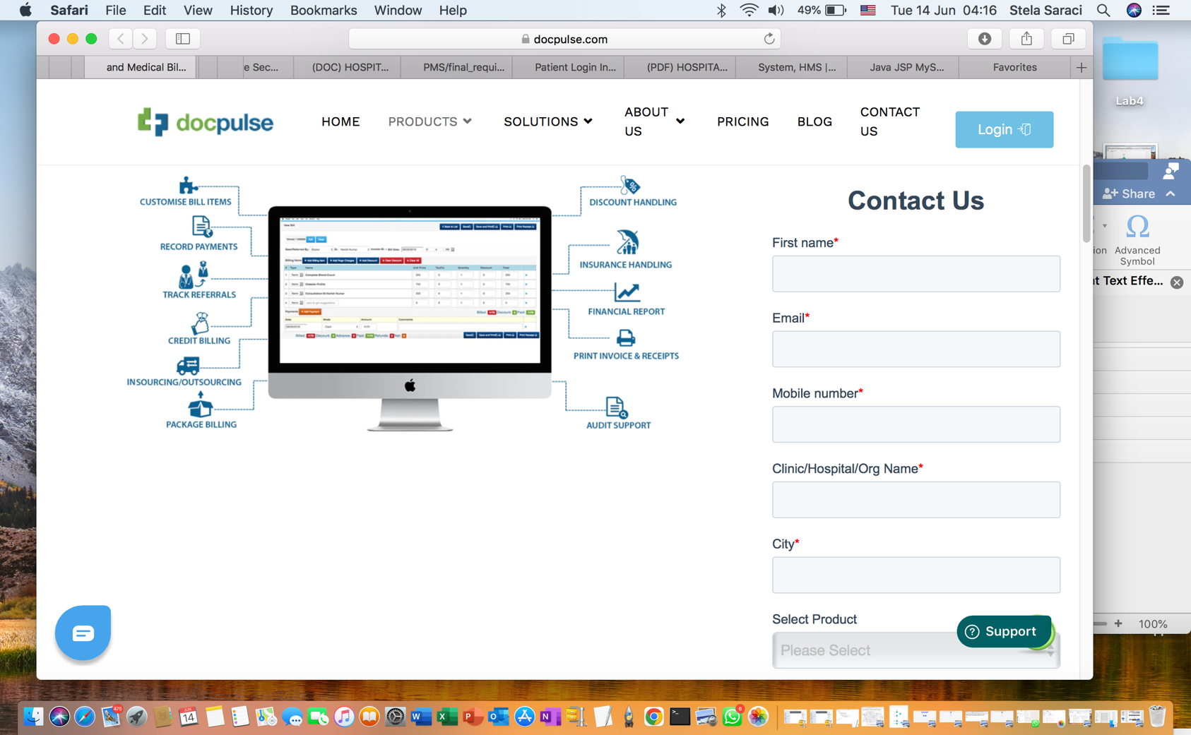

PRINTED BILLS AND RECIEPTS

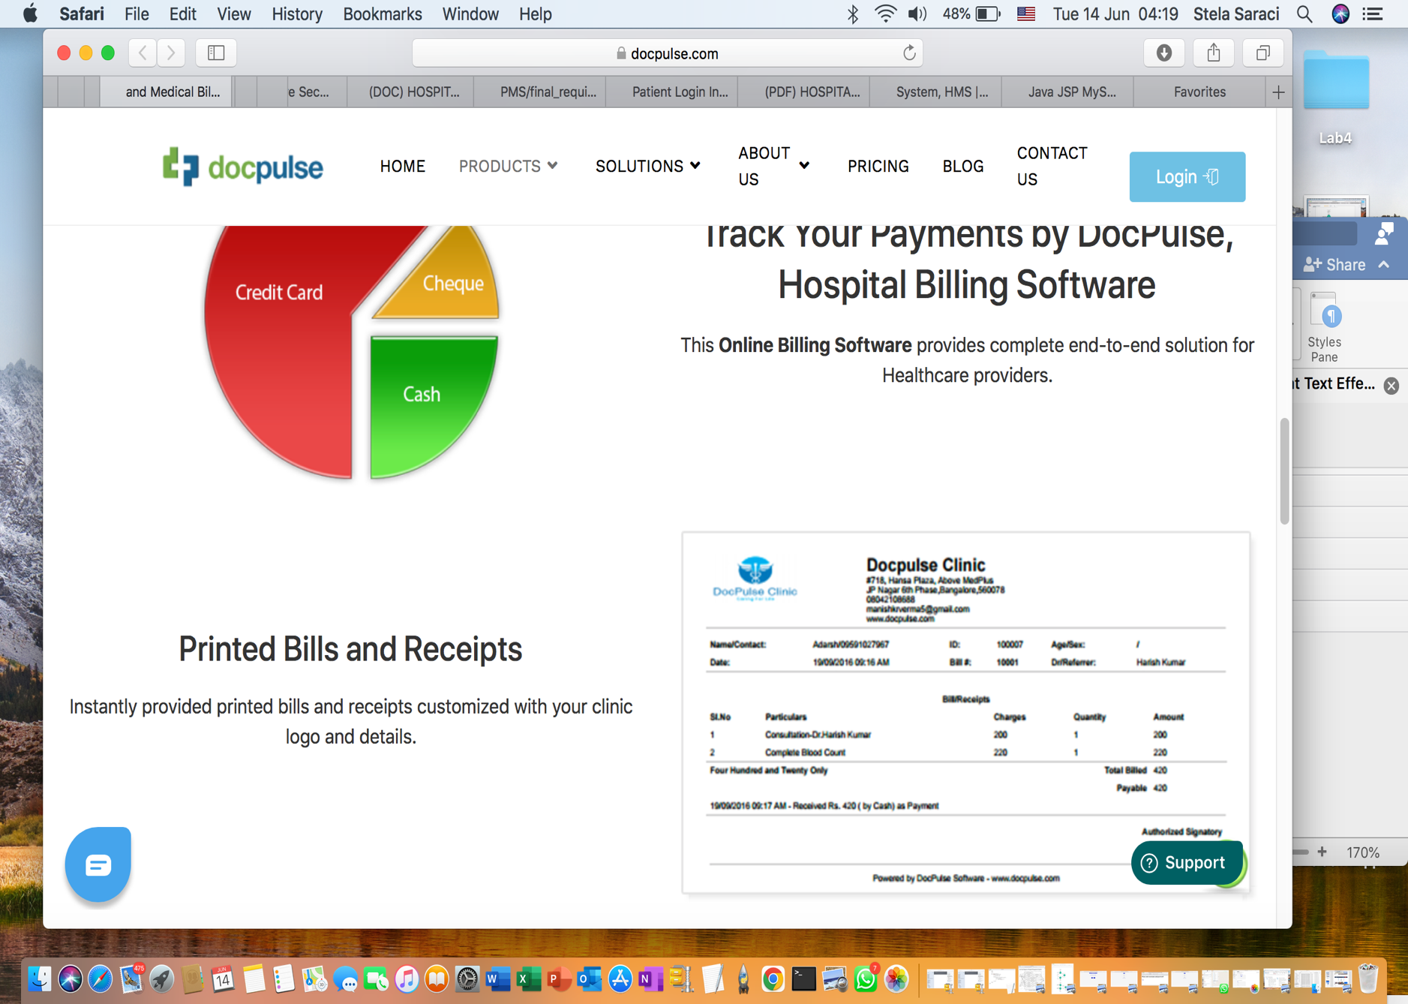



San Luca Clinic

PACKAGES AND SHARING

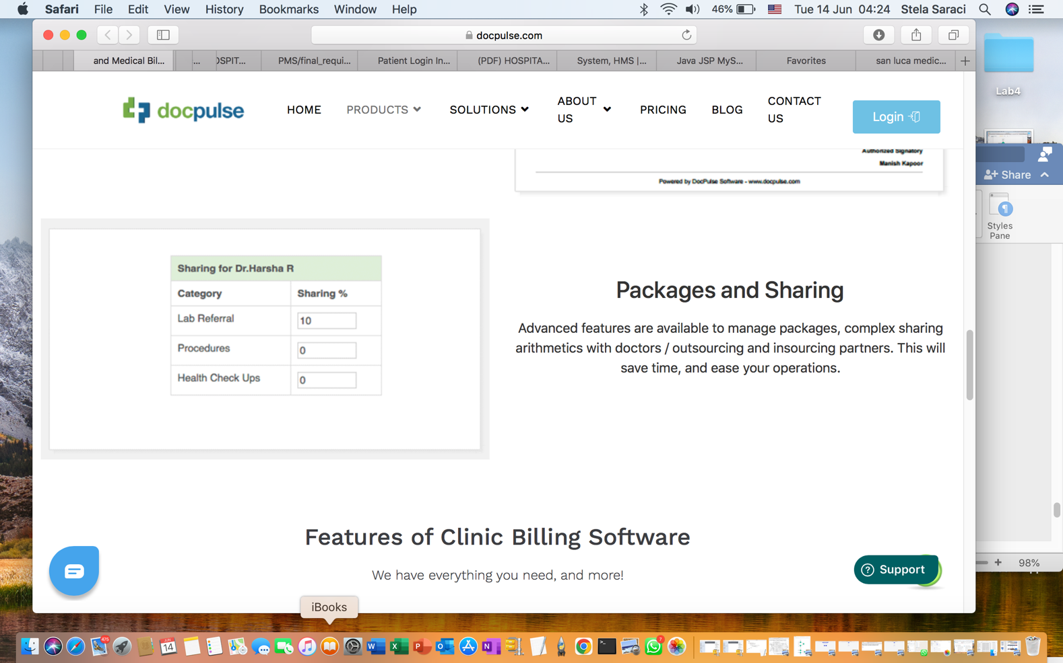

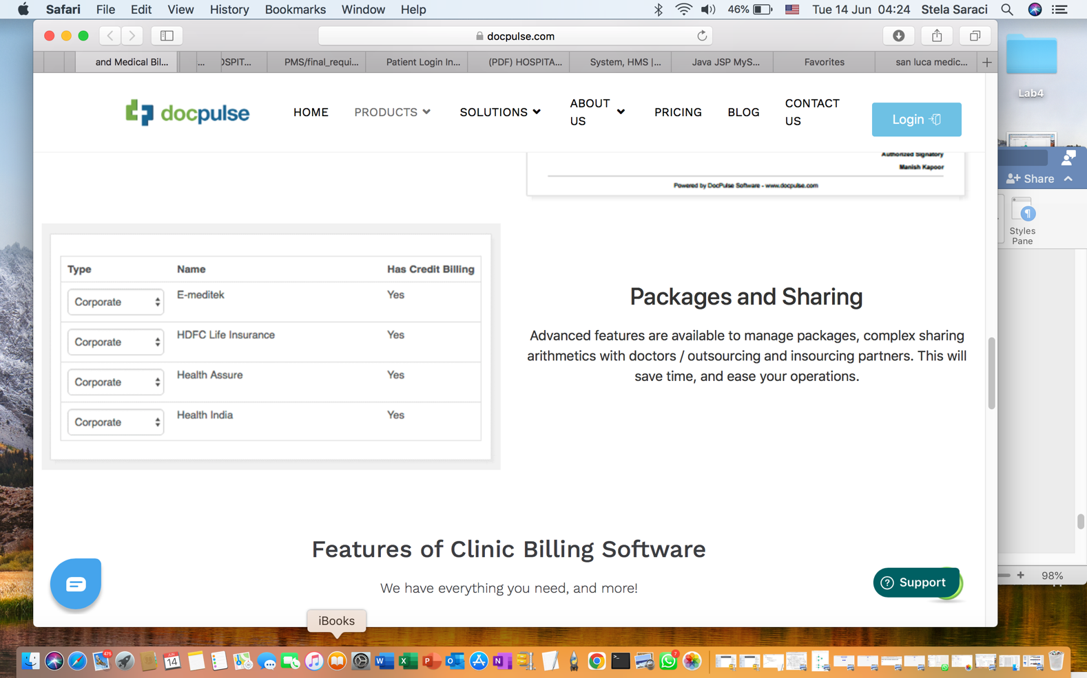

FEATURES OF SAN LUCA MEDICAL SOFTWARE

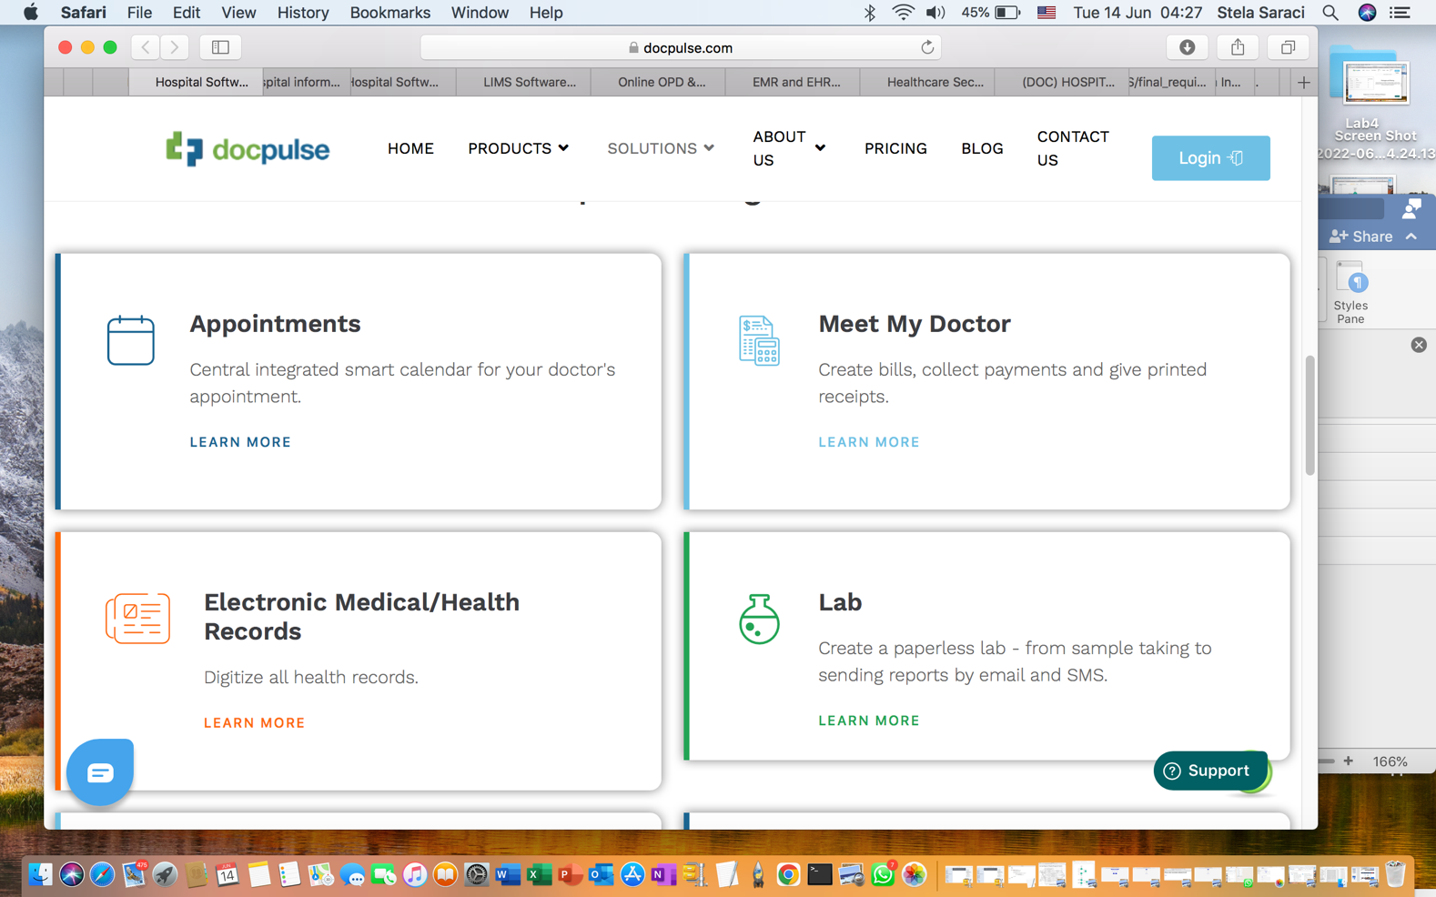

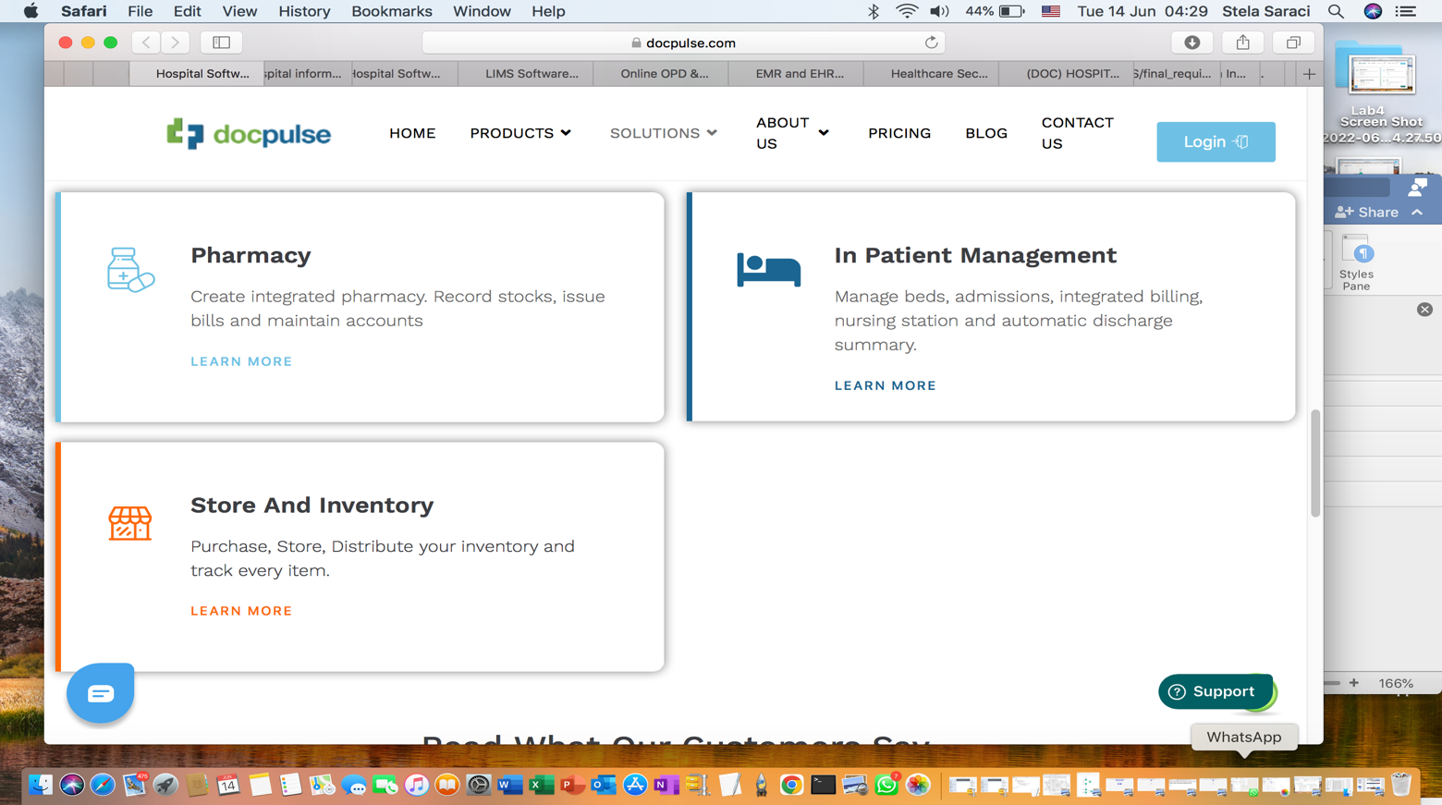

FEATURES OF SAN LUCA SOFTWARE

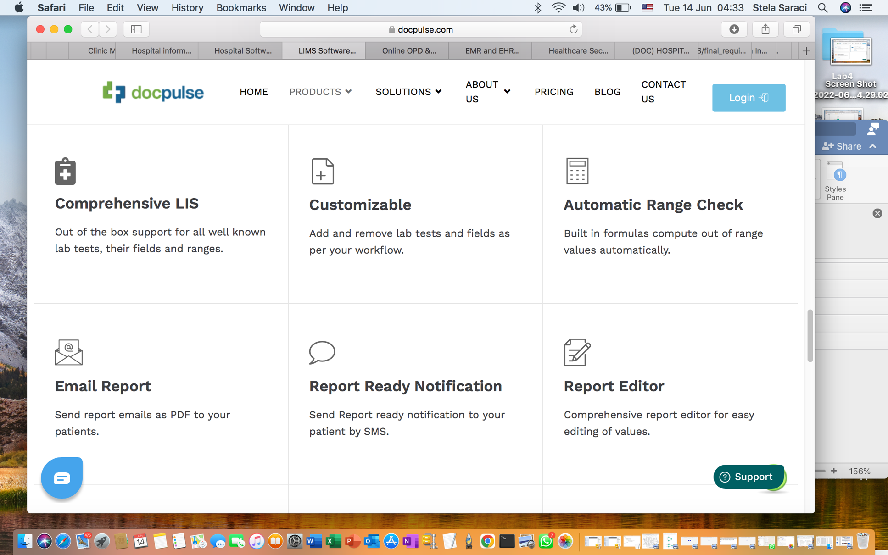

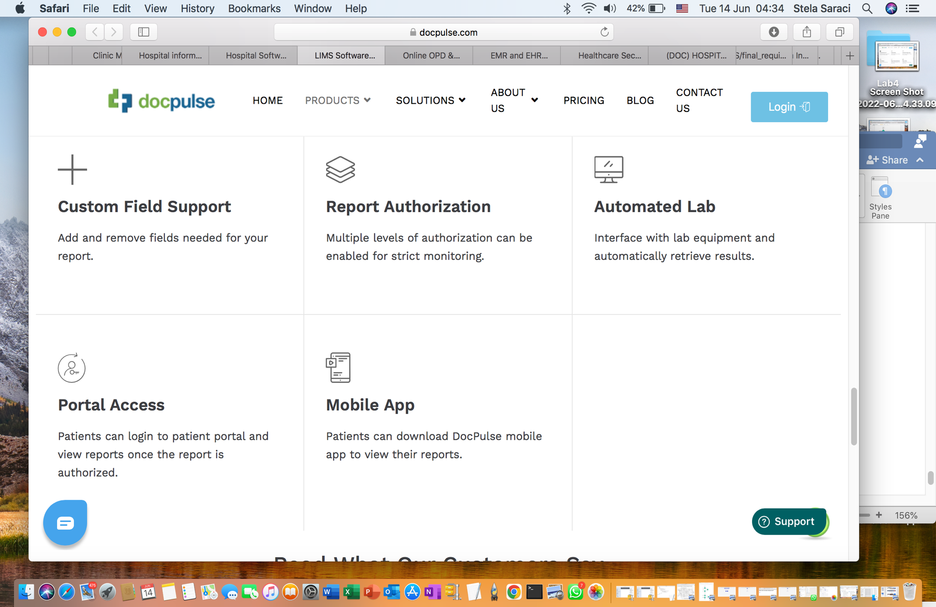

LEAVE APPOINTMENT WITH DOCTOR

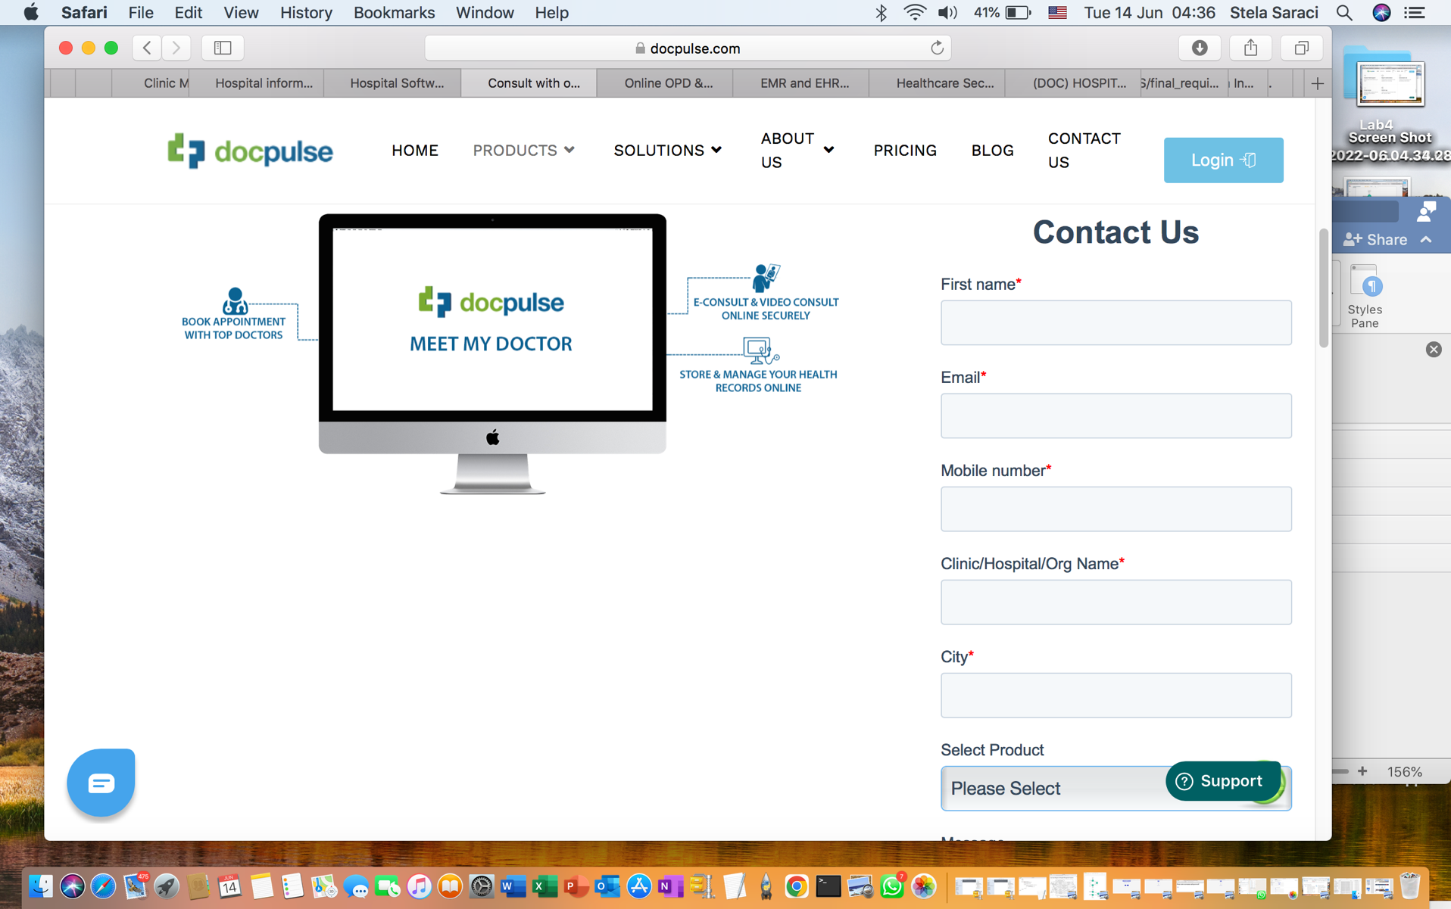

SAN LUCA CLINIC

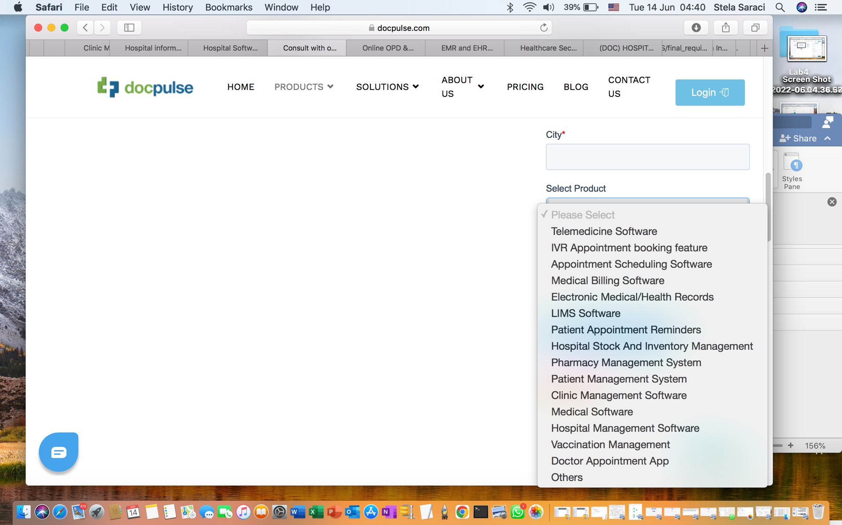

Leave a consult with dermatologist

Leave an appointment with oculist

Leave an appointment with endocrinologist

Leave an appointment with gynecologist

Leave an appointment with neurologist

Reserve a meeting

Cancel meeting

VACCINATION MANAGEMENT SYSTEM

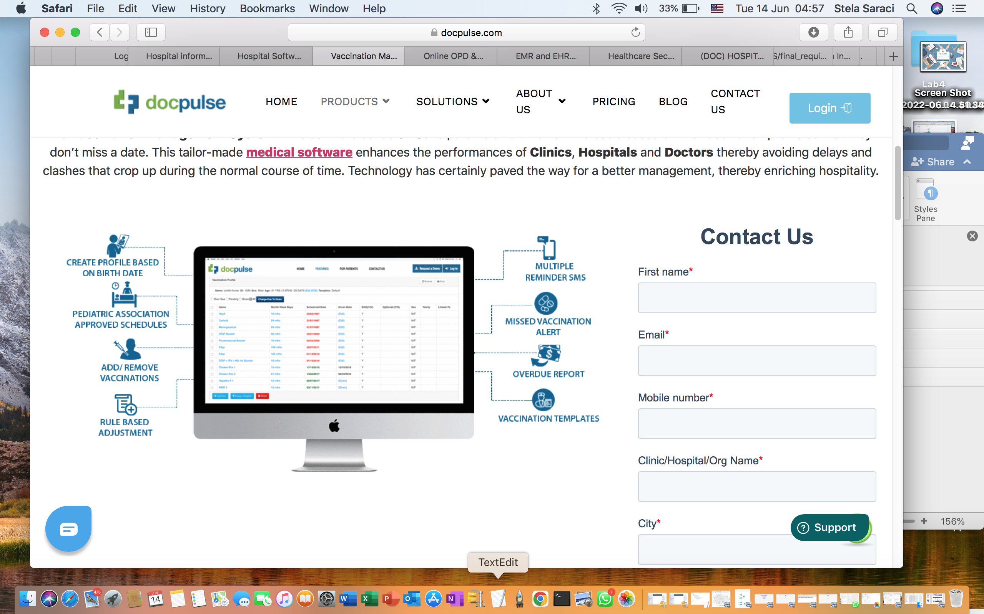



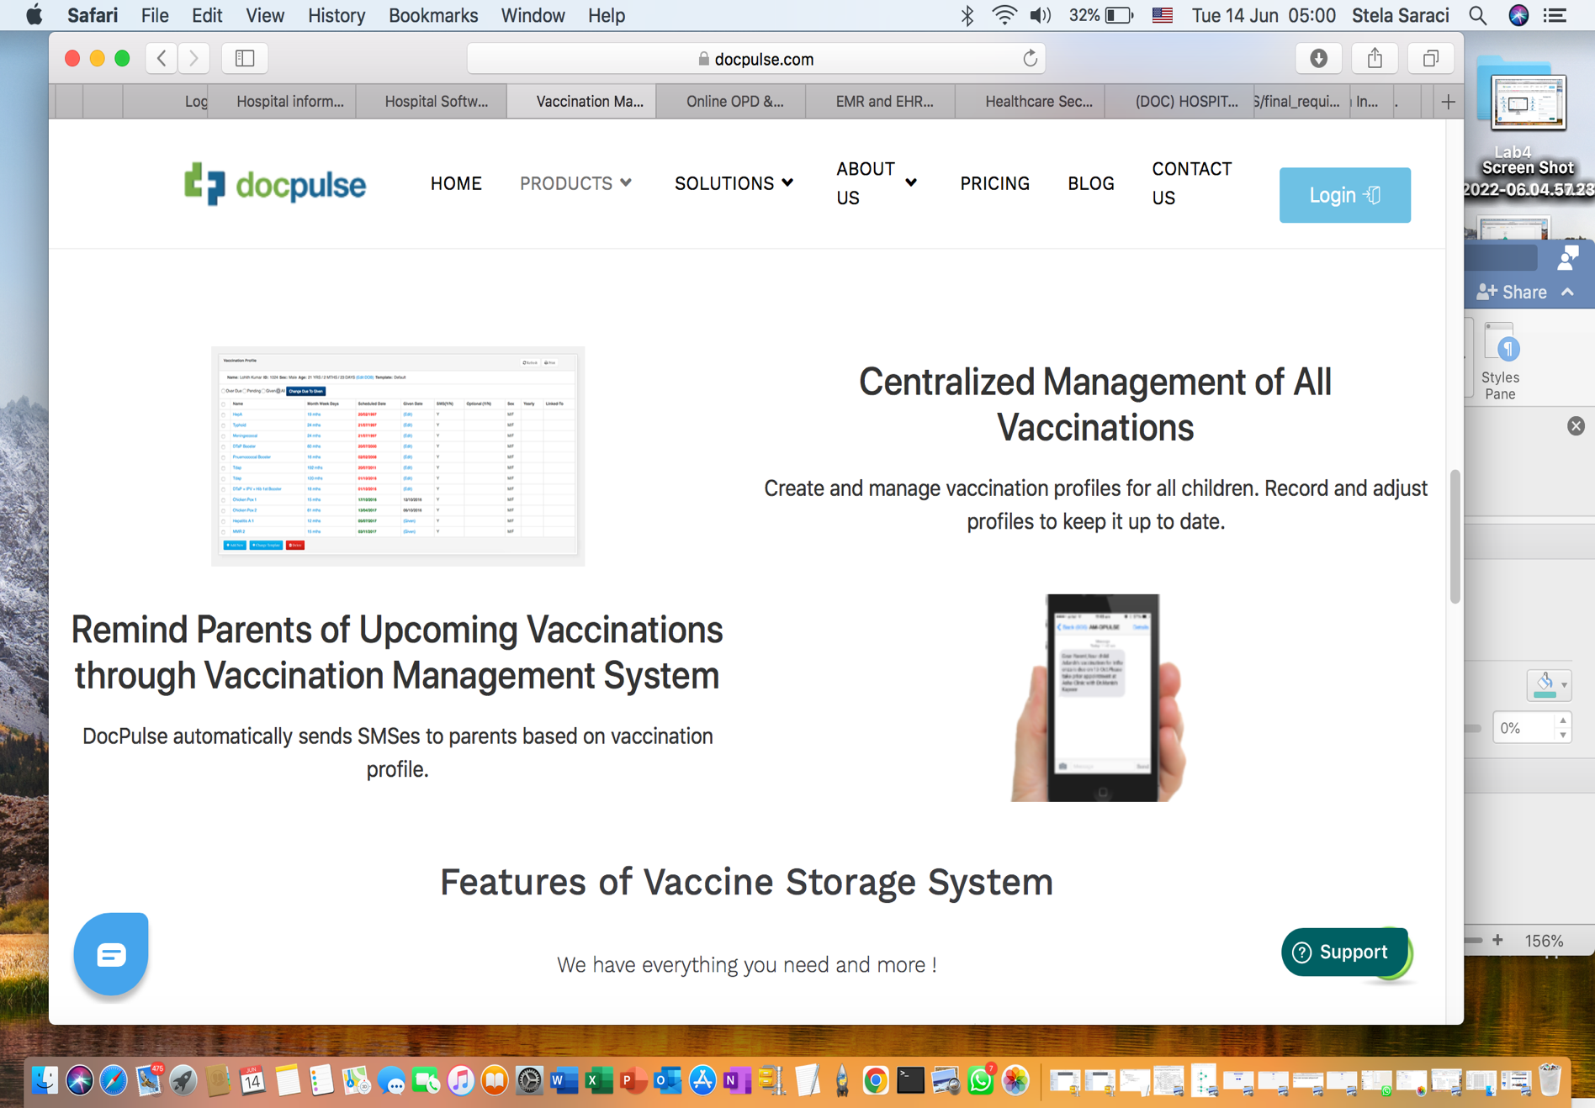

San Luca automatically sends SMS to parents based on vaccination profile

MAIN PAGE

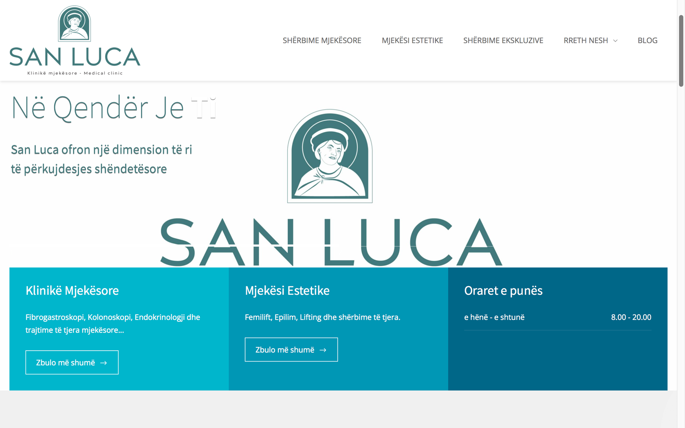

BLOG

ABOUT US

EXCLUSIVE SERVICES

ESTHETICS

MEDICAL SERVICES

Time

Monday-Saturday

Esthetics

Epilim, Lifting and more services

Discover more

Discover more

Discover more

Medical Clinic

Endoscopy and more Medical treatments…

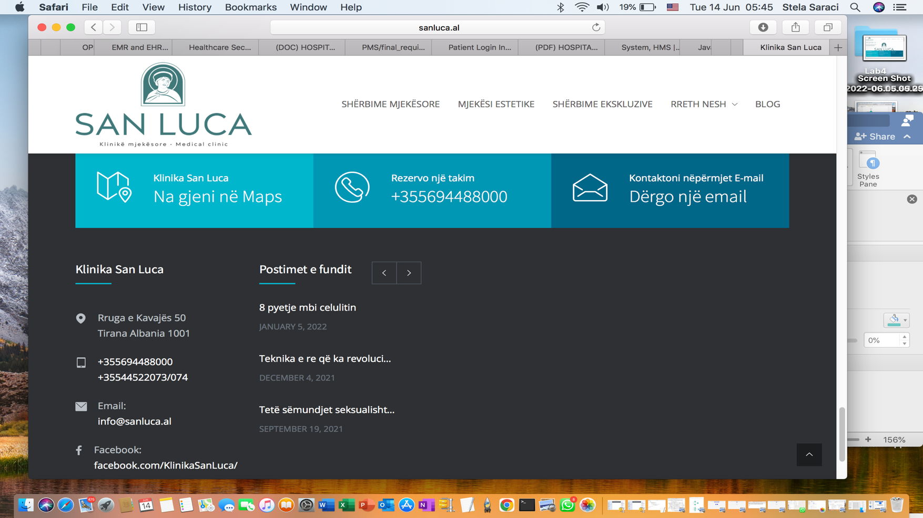

Latest Posts

COVID-19

Vaccination

Laser Treatment

SEND EMAIL

Find us on google maps

BLOG

ABOUT US

EXCLUSIVE SERVICES

ESTHETICS

MEDICAL SERVICES

RESERVE A MEETING

PRODUCT CONTEXT

**DERMATOLOGY**

Acne Treatment

CO2 LASER, Mesotherapy

Rosacea treatment

**GYNECOLOGY**

Cervical Dysplasia

PCOS

Ultrasonic echo

**ENDOCRINOLOGY**

**ABDOMINOPLASTY**

Liposuction

Adrenal Gland Surgery

Appendectomy

**PEDIATRY**

Pediatric Consultation

Pediatric Abdominal Ultrasound

Pediatric Thyroid Ultrasound

Neonatal Coxofemoral Ultrasound

Pediatric Endocrinological Consultation

Metabolic tests

Analysis of Pediatric Anemia.

**PHLEBOLOGY**

Doppler ultrasound

Sclerotherapy

Phlebotomy

Vascular surgery

|  |  |  |  |
| --- | --- | --- | --- |
| |  | | --- | | Klinika San Luca | | our vision Pulse Green Flat Icon Heart Rate Sign Stock Photo, Picture And Royalty Free  Image. Image 38136482.  We are focused on bringing the highest standards in Albania in the medicine field with the most advanced treatments and technology that will help our patients have an improved well-being.  Natural Face Cream Jar Green Flat Design Long Shadow Glyph Icon Skincare  Product Chemical Free Facial Hydrating Lotion Skin Treatment Organic  Cosmetics Vector Silhouette Illustration Stock Illustration - Download  Image Now - iStock    TREATMENTS    San Luca offers treatments in various fields such as dermatology ,gynecology ,endocrinology and so more.  Cities and Coronavirus (COVID-19) HEALTH PACKAGESan Luca offers a health package for all its patients After numerous procedures, diagnostics according to the treatment, each patient receives his personalized package Location Marker Icon Google Maps Pointer Elsavadorla - Google Map Marker  Green Transparent PNG - 445x720 - Free Download on NicePNG FIND US ONGOOGLE MAPS Kavaja Street 50 Tirana Albania 1001  Phone Number Icon #233015 - Free Icons Library  Letter Email Round Green Icon Transparent PNG | Citypng  sanluca@info. +355694488000 | | Doctor List of Derma Bloom Skin, Hair And Laser Clinic in Sanath Nagar,  Hyderabad | Drlogy  Pediatrics in Lucedale, MS - Lucedale Pediatrics  Nurse Icon Vector Art, Icons, and Graphics for Free Download  Abdominoplasty Four Color Glass Button Icon Free Stock Vector Graphic Image  Pediatric Endocrinology Color Glyph Icon. Checking Children Stock Vector -  Illustration of icon, drawing: 219593977  Gynecology Icon Images | Free Vectors, Stock Photos & PSD  Cystic Fibrosis  Adrenal Insufficiency  Acromegaly |









Leave a consult

Reserve a meeting

Choose Doctor

**PEDIATRY**

Pediatric Consultation

Pediatric Abdominal Ultrasound

Pediatric Thyroid Ultrasound

Neonatal Coxofemoral Ultrasound

Pediatric Endocrinological Consultation

Metabolic tests

Analysis of Pediatric Anemia.

Leave a consult

Reserve a meeting

Choose Doctor

**DERMATOLOGY**

TREATMENT OF PSORIASIS

DERMATOLOGICAL SURGERY

TATTOO REMOVAL